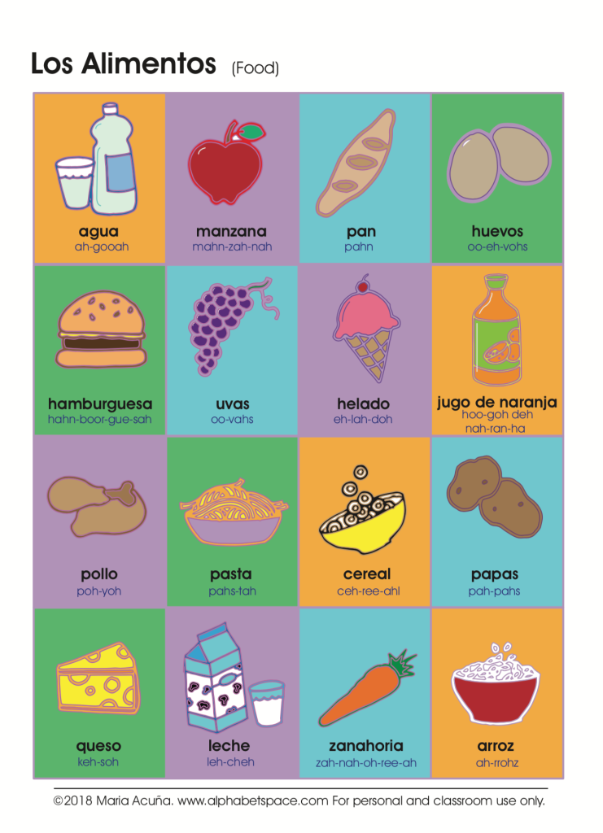

**MFL Year 5**

**Spring Term**

**Hobbies, Numbers to 50, Food**

el pastel – cake

las galletas – biscuits

be bolsa - crisps

los guisantes - peas

la ensalada - salad

pero - but

magdalenas - muffins

chocolate con churros – hot chocolate with churros

un zumo de naranja – Orange juice

quisiera – I would like

**Key Vocabulary:**

jugar al - Play

nadar - Swim

voy a – I’m going to

otra vez – Once again

treinta – thirty

cuarenta – forty

cincueta – fifty

el pescado - fish

el yogur – yoghurt

**Key Facts:**

School lunches in Spain are usually 3 courses, not two.

**Key Questions:**

¿Que vas a hacer?

¿Quieres……….?

**Things I can already do:**

Understand key information from a short exchange

Listen to a native speaker and understand more complex phrases and sentences

Recite a short text with accurate pronunciation

Memorise and present two/three sentences using descriptive words

Manipulate language by changing an element in a sentence

Take part in a simple conversation

Understand and express simple opinions

Make a simple sentence and manipulate them by changing an element

Write short sentences, substituting vocabulary in model sentences

Understand a short story containing familiar vocabulary

Identify the position of adjectives in a sentence

Substitute quantifiers and adjectives in a sentence