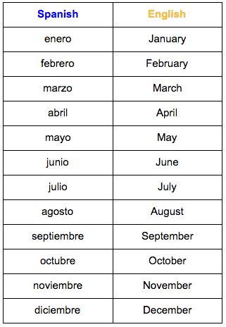
MFL Year 3
Summer Term
Food, Days of the Week, Months of the Year

Key Vocabulary:
las naranjas - oragnes
las peras - pears
las ciruelas - plums
las fresas - strawberries
las manzanas - apples
los tomates - tomatoes
los plátanos - bananas
es Bueno – It is good
es mal – Is bad
la coca-cola - Cola

la limonada – Lemonade
el helado – Ice cream
la pizza - Pizza
el chocolate - Chocolate
los caramelos - sweets
las patatas fritas - crisps
las piruletas - lollipop
el queso - Cheese
el jamón - ham
¿te gusta? – Do you like?
los dias de la semana – The days of the week

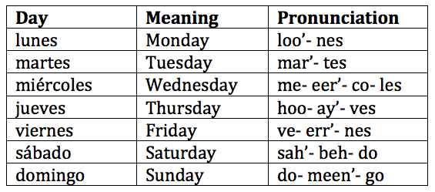
Things I can already do:
Read familiar words with accurate pronunciation
Respond to a question and try to give an extended answer
Experiment with writing by producing short sentences using verb, adjective and connective
Make links between some sounds and spellings and recognise familiar words in written form
Understand and respond to a question

Key Facts:
The days of the week and the months of the year do not have capital letters in Spanish.
Key Questions:
¿Te gusta?

¿Te gustan?

