**Curriculum pathway:**

**Key Vocabulary**

Meditation - a practice for calming one's mind and body

Waheguru - The name most widely used for God by Sikhs

Khalsa - a group into which committed Sikhs can be initiated to demonstrate their devotion to their faith

Oppression - cruel or unjust use of authority or power

Self-sacrifice - the giving up of what you want so that other people can have what they need or want

Langar - the communal meal shared by all who come to the gurdwara

Amritsar - also known as the Golden Temple, the main place of worship of

the Sikhs

Stable - a building in which livestock, especially horses, are kept

Account - a detailed record of things

Version - something a little different from others of the same type

**R.E Year 5**

**Autumn Term**

**Sikhism/Christianity**

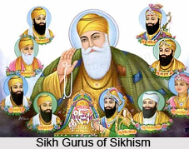

**Key Facts**

The five key Sikh beliefs are:

God is in everything

It is a Sikhs duty to serve others

All people should be treated as equals

Sikhs should share what they can with others

Sikhs should earn their living honestly

The purpose of life for a Sikh is to see and speak with god

Christians believe God gave Jesus to the Earth to show people how to lead good lives, forgive them for the things they do wrong and prove to them that there is life after death.

**Key Questions**

How far would a Sikh go for his/her religion?

Is the Christmas story true?