**Curriculum pathway:**

**Key Vocabulary**

Exchanged - the act of giving or taking one thing in return for another

Eternity - forever

Unconditional - the person doing or giving it does not require anything to be done by other people in exchange

Agape - having the mouth open in wonder or surprise

Heaven - the place where God lives, where good people go when

they die, and where everyone is always happy

Harvest - When a crop has grown and is ready to eat, the farmer

must collect it from the fields

Oath - a promise

**R.E Year 6**

**Spring Term**

**Christianity**

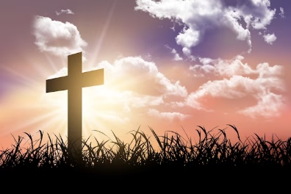

**Key Facts**

Christians believe that because of Jesus’ resurrection, Christians will also be able to have life after death (eternal life).

Christians believe Jesus made forgiveness possible by His crucifixion.

Humanists believe there is no god, there is one life and when it is over that is the end.

**Key Questions**

Is anything ever eternal?

Should religious people be sad when someone dies?

How well do funeral and mourning rituals tell you about what a religion believes and about what happens after death?

Is Christianity still a strong religion 2000 years after Jesus was on Earth?

Is religion the most important influence and inspiration in everyone’s life?