**Curriculum pathway:**

**Key Vocabulary**

Turban - a head covering made of a long cloth wrapped around the head

Gurus - teacher, guide, expert, or master

Vand Ke Chakna - o share what you have and to consume it together as a community

Seva - to use whatever skill/ability you have to serve others

Kirat Karnee - doing something that is honest, truthful, and will help you

do something good for your family/community

Akal Takhat - one of five seats of power of the Sikhs

Conceitedness - having or showing too high an opinion of oneself

**R.E Year 5**

**Summer Term**

**Sikhism/Christianity**

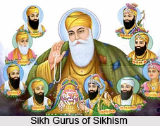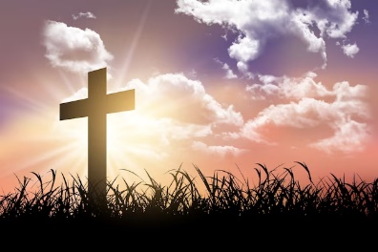

**Key Facts**

Sikhs cover their hair to make them stand out in a crowd of people, they want to be easily recognisable so that everyone knows that help, care and kindness is at hand whenever they need it.

The Sikh turban represents love, care, kindness and protection against unkindness.

Christians show commitment to God by attending church every Sunday/worshipping God.

Christians believe that praying to God shows commitment.

**Key Questions**

What is the best way for a Sikh to show commitment to God?

Do all religious beliefs influence people to behave well towards others?

What is the best way for a Christian to show commitment to God?