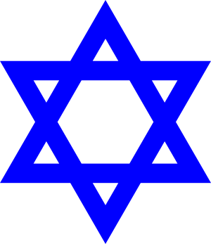

**Curriculum pathway:**

**Key Vocabulary**

Agreement - When people feel or think the same way about something, they agree and sometimes write it down or make a promise

Consequence - what happens immediately after a behaviour

Covenant - a formal agreement, a promise made between two people

Descendants - their children, their children's children, and all the people who live after them who are related to them

Torah scroll - a long scroll containing the entire text of the Five Books of Moses, hand-written in the original Hebrew

Mezuzah - a small box that is placed on the right doorpost of Jewish homes

Shema - the oldest prayer that Jews say

Affirmation - phrases or statements that, when you repeat them regularly can shift negative thought patterns and promote positive thinking, self-esteem, and

motivation

Symbol - a mark, sign, or word that indicates or represents an idea, object or relationship

Manger - a wooden or stone feeding trough or food box that holds hay for

larger farm animals like cattle, horses, and donkeys

Christingle - a festive, candle-lit Christian celebration that takes place during

Advent

**R.E Year 4**

**Autumn Term**

**Judaism/Christianity**

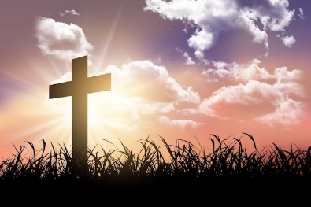

**Key Facts**

Jews believe that there is one God who not only created the world, but with whom every Jew can have a personal and individual relationship.

Jewish people believe that God has always kept his promise to look after them.

The angel symbolises that Jesus was not just an ordinary man.

The wise men and the Shepherds are an interesting contrast between rich and poor, symbolising that Jesus is a gift from God to everyone.

The stable continues to represent humble beginnings

**Key Questions**

How special is the relationship Jews have with God?

Do sacred texts have to be ‘true’ to help people understand their religion?

Does participating in worship help people to feel closer to God or their faith community?

What is the most significant part of the nativity story for Christians today?