**Curriculum pathway:**

**Key Vocabulary**

Bar Mitzvah - a coming of age ceremony for Jewish boys when they reach the age of 12 or 13

Bat Mitzvah - a coming of age ceremony for Jewish girls when they reach the age of 12 or 13

Rite of passage - milestones of life celebrated through different rituals and ceremonies in different world religions

Ceremony - an activity performed at a special time usually with according

Confess - the act of admitting that you have done something wrong or illegal

Baptise - a sacrament usually performed by a priest

Vicar - an Anglican priest who is in charge of a church and the area it is in, which is called a parish

Priest - is a member of a church that has been told to look after his (spiritual) community.

Faith - a belief and trust in God based on evidence but without total proof

Hypocrite - a person who claims or pretends to have certain beliefs about what is right but who behaves in a way that disagrees with those beliefs

**R.E Year 4**

**Summer Term**

**Judaism/Christianity**

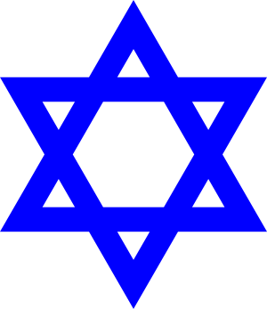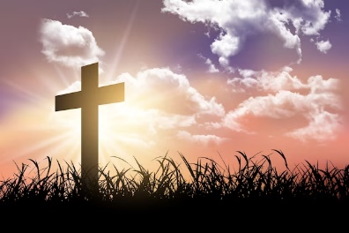

**Key Facts**

Prayer and worship at home and at the synagogue are important ways Jews show commitment to God.

John the Baptist was Jesus’ cousin.

Communion is celebrated towards the end of mass as a reminder of the last meal Jesus had with his disciples.

**Key Questions**

What is the best way for a Jew to show commitment to God?

Do religious people lead better lives?

Does participating in worship help people to feel closer to God or their faith community?

Do people need to go to church to show they are Christians?