**Curriculum pathway:**

**Key Vocabulary**

Mosque - place of prayer for Muslims, or followers of the religion of Islam

Worship - to honour God and show Him your love

Ummah - the whole Muslim world, or the community of believers

Prophet - someone chosen by God to be a messenger

Hajj - the pilgrimage to the holy city of Mecca in Saudi Arabia

5 pillars - believing in Allah and His Messenger, praying, fasting, giving charity, and performing Hajj

**R.E Year 2**

**Summer Term**

**Islam**

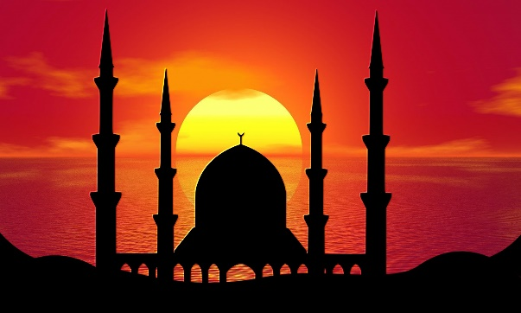

-

**Key Facts**

Muslims believe that praying together in groups brings greater blessings than praying alone.

By completing Hajj, Muslims are showing a commitment to God (Allah).

God is really important to Muslims and they are prepared to make lots of effort to show him this.

Hajj is one of the 5 pillars and one of the 8 doors to heaven.

**Key Questions**

Does going to a mosque give Muslims a sense of belonging?

Does completing Hajj make a person a better Muslim?