**Curriculum pathway:**

**Key Vocabulary:**

Senses - Senses allow us to observe and understand the world around us.

Amphibians – A cold blooded animals that live partly on water and partly on land

Reptiles – Cold-blooded animals that have scales and can lay eggs

Mammals – Humans and animals that are warm-blooded with hair.

Carnivore – An organism that eats mostly meat

Herbivore – An organism that feeds mostly on plants

Omnivore – An organism that consumes a variety of meat and plants

Adults – Anyone over the age of 18

Air – A mixture of different invisible gasses

Hygiene – The way we care for our bodies

**Science Year 1**

**Spring Term – Eco Warriors**

**Animals including Humans**

**Seasonal Changes**

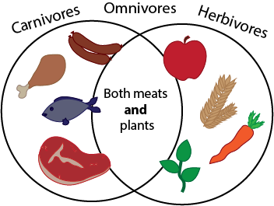

**Key Facts:**

The five senses are smell, touch, hear, feel and taste.

Animals and human beings need food, water, air, and shelter to survive.

Exercising is good for humans.

Spring is the season when plants start to grow again.

Sustainable development goals

**Key Questions:**

What senses do humans have?

How do humans change as they get older?

What are the basic needs of humans?

What do humans need to do to stay healthy?

What do animals need to help them survive?

What happens to the environment in Spring?