**Curriculum pathway:**

**Key Vocabulary:**

Habitat - Places where animals and plants live

Shelter - What people and animals use to protect themselves from their surroundings

Microhabitat - A small area that differs from the surrounding habitat Deforestation when humans cut or burn down large areas of forest

Deforestation – The action of clearing a wide area of trees

Food Chain - A sequence that describes how animals eat each other

Producers - Plants are producers because they use light energy from the sun to produce their own food

Consumer - Organisms that eat other living things including plants

Respiration - The process all living things go through to create the energy they need to live

Excretion - The process of eliminating waste products

Reproduction - The process in which a living organism produces a likeness of itself

**Science Year 2**

**Summer Term – The Great British Seaside**

**Living things and their habitats**

**Plants**

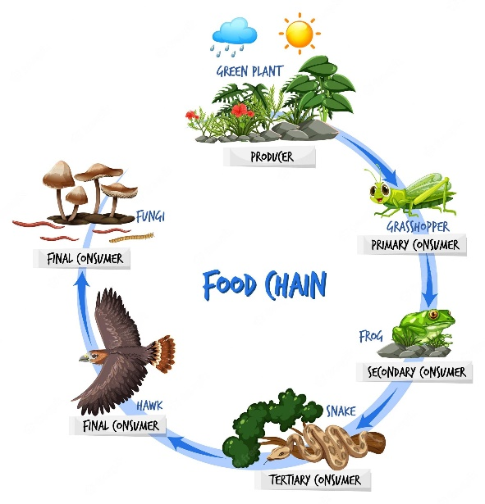

**Key Facts:**

A habitat must provide food, shelter, water and space.

Different animals will require different things from their habitat.

Habitats can change in many ways.

A food chain shows how animals depend on plants and other animals for their food and survival.

A food chain can tell you about what animals eat.

**Key Questions:**

What types of habitats are there?

How do animals adapt to certain habitats?

How do animals depend on each other?

How do habitats provide what is needed for animals?

What is a food chain?

What is a food source?

How do plants obtain the food?

How do habitats change?