**Curriculum Pathway:**

**Key Vocabulary:**

Muscle - Long threads or fibres under the skin that control movement  
Skeleton - The framework that the bones of the body form  
Lungs - Bag like organs or body parts used for breathing  
Diaphragm - Dome shaped sheet of muscular tissue below the chest cavity  
Biceps - Muscle in your arm  
Triceps - Large muscles along the back of your upper arm  
Diet - The sum of food eaten by animals and humans  
Nutrition - The study of food and how it works in your body  
Vertebrate - An organism that has a backbone  
Invertebrate - Animals without a backbone or bony skeleton

Xylem - Carries water from the roots to all parts of the tree or plant

Transportation - The movement of water and nutrients to all parts of the plant

Pollination - How insects help plants to make seeds

Seed dispersal - The way seeds are carried or spread to other places.

**Science Year 3**

**Spring Term – Here, There and Everywhere**

**Animals including humans**

**Plants**

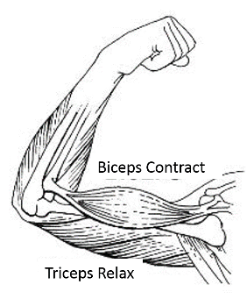

**Key Facts:**

Animals can be grouped according to their bone structure.

Animals can be grouped according to what they eat.

Some seeds are transported by wind, and have seeds designed to float, glide or spin through the air.

Plants growing near a river may use the flowing water to transport their seeds.

Sometimes animals can move seeds.

**Key Questions:**

What is diet and nutrition?  
Do all animals have a skeleton?   
How do muscles work?

How is water transported through plants?

What are the ways plants disperse their seeds?