Co-op Academy Penny Oaks
LONG TERM PLANNING – Year 2
 | Autumn | Spring | Summer
Topic | Transport-  History of Flight | My Country, My City | Oh, I do Like to be beside Seaside
R.E | Christianity (Autumn 1)  Christianity (Autumn 2) | Judaism Islam (Autumn 1)  Christianity (Autumn 2) | Islam (Autumn 1)  Islam (Autumn 2)
Science | Plants  Animals including humans | Plants  Materials | Plants  Living things and their habitats
PSHE/RSE | Co-op Values- Self help  Story project  Happy Mind  Meet your brain | Story project  Happy Mind  Celebrate  Appreciate | Story project  Happy Mind  Engage  Relate
English Texts | Fiction: Adventure story  Emma Jane’s Aeroplane  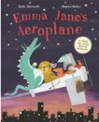  Poetry: black out poetry  Non-fiction: Letter to Amelia Earhart  Fiction: I am Amelia Earhart  Story of a girl who was the first woman to fly over the Atlantic Ocean  (transport, aspirations, adventure)  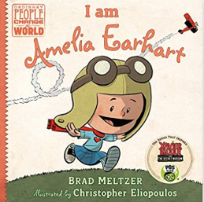  Non-fiction:  Information text about types of transport (purpose of the text: children publishing their texts on class transport exhibition)  Guided Reading and Class Text  Taking Flight: How the Wright Brothers Conquered the Skies  Whoever Heard of a Flying Bird? David Cunliffe  Here We Are by Oliver Jeffers  Mixed Up Fairy Tales  Kites by Simon Mole  Cherry Blossom and Paper Planes | Fiction: Seeds of Friendship by Michael Foreman  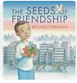  Non-fiction: Recount from The Pantomime experience  Non-fiction-Diary entry  Invisible by Tom Percival  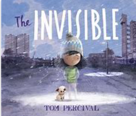  Fiction: A story based in Bradford  Poetry: City poems  Guided Reading and Class Text  All Through the Night: The People Who Work While We Sleep  Beegu by Alexis Deacon  Poems Aloud  The Secret Sky Garden Linda Sarah  On Sudden Hill by Linda Sarah  Coming to England by F. Benjamin  Small Mouse Big City by S. Prescot | Storm whale by Benji Davies  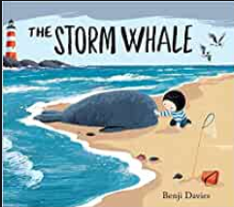  Non-fiction: Instructions  How to Save a Beached Whale  Poetry: Sea poems (Rhymes  Fiction:  Environmental story  Little Turtle and the sea  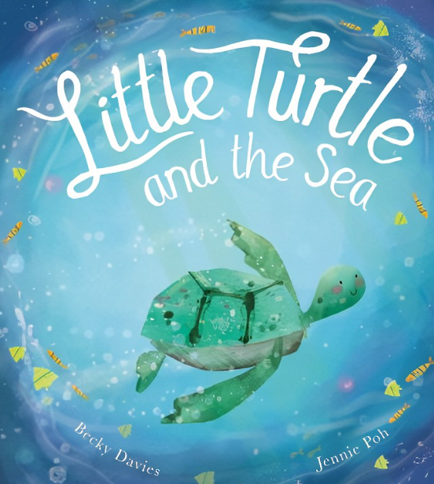  Letter to David Attenborough  About plastic pollution based on the Somebody Swallowed Stanley and other environmental work done in class.  Poetry: sea poems  Guided Reading and Class Text  Great women who saved the planet  By Kate Panhurst  The Big Book of Blue  by Yoval Zommer  Lubna and Pebble by W. Madour  Dolphin Boy by M. Morpurgo  One World by M. Morpurgo
Maths | Chapter 1 – Numbers to 100  Chapter 2 – Addition and Subtraction  Chapter 2 – Addition and Subtraction  Chapter 11: Geometry – Properties of Shapes: 2D Shapes  Chapter 10 – Measurement: Money | Chapter 3-Multiplication 2, 5 and 10’s  Chapter 4 – Multiplication and Division of the 2’s, 5’s and 10’s  Chapter 8-Chapter 8: Statistics: Pictograms  Chapter 9 – Word problems  Chapter- 14 Time  Chapter 5 – Length  Chapter 7-temperature | Chapter 13– Fractions  Chapter 12 – 3D shapes  Chapter 14-Time  Chapter 6- Mass  Chapter 15- Volume
Cross Curricular  Maths | NowPressPlay-Number bonds  Length-How far did our kites fly? | 3D shapes- buildings around Bradford | Measure-capacity linked to seaside
Computing | Computer Science  Digital Literacy  Online Safety | Media  Data Handling  Online Safety | Computer Science  Media  Online Safety
P.E | Invasion games -Football  Gymnastics | Dance  Basketball | Tennis  Athletics
Art | Leonardo Davinci and his flying machines- sketching techniques  Making planes using recycled materials  Starting sketchbooks  Patterns-feathers,  Air balloons  Christmas cards  Clouds-textures | Wax water-resistant buildings  Great Victoria hotel in Bradford photograph-recreate the other half (charcoal)  City skyline Bradford silhouette  Cityscapes  Bradford’s historical back to back houses-perspective  Observational drawings-our street  Mick Manning-Local illustrator  Alhambra- sketching  Easter cards  Mother’s Day cards | Nature sculptures  Seascapes- paintings  Seascapes- collages Ann Steer-seascapes  Clay sea creatures  Charcoal and wax crayons lighthouse  Wax whale- watercolours  Treasure maps
DT | Healthy snack - Flap jacks and seed bars  Preparing a healthy meal for a pilot  (Look and Cook Primary School Programme) | Designing and making pantomime puppets  Yorkshire Puddings  (Look and Cook Primary School Programme) | Windmills  Fruit Lollies  (Look and Cook Primary School Programme)
History | Wright Brothers  Amelia Earhart | Francis Laidler-The pantomime King  Our heritage-Bradford | The great British seaside/changes over time  Victorian seaside
Geography | Continents of the world | UK Bradford  My Country- My City  Local Study | The Great British seaside  Seaside features and contrasting locations
Spanish | On the Farm  Autumn Walk & Harvest | Birthday Party  Me & my puppy | Over the Rainbow  Pirate Personalities
Music Tuition | Singing | Singing | Singing
Music | Composer -Anna Clyne and Elvis Presley  Rock and Roll  Elvis Presley- Hound Dog | Composer- Ravel, Bolero (20th Century)  Pop: The Beatles- With a little help from my friends. | Musical traditions-  Indonesia, Gamelan- Baris, Gong Kebyar of Peliatan
Experiences | Pilot visit  Autumn walk-signs of Autumn  Visit to York air museum | Pantomime - Alhambra  Playhouse  Bradford walk-Leeds Road (what’s on our street?) | Filey trip  Habitat hunt  QR hunts
Opportunities for Outdoor Learning | Planting Autumn Bulbs  Autumn Maths outside-sticks and acorns  Art hunt  QR hunts | Bradford Walk-geography  Sketching on the hill  Maths hunt-arithmetic (four calculations)  QR hunts | Features of the seaside-geography  Habitats at the seaside -science  Plastic pollution  QR hunts
Opportunities for Aspirations | Pilot visit  Amelia Earhart-female pilot  Perseverance-Wright Brothers | Francis Laidler-I am proud to be local  Mick Manning-artist born in Haworth | David Attenborough-saving the planet  Ann Steer-Female modern artist
Opportunities for Healthy Lifestyles/Nutrition | Autumn Walk  Preparing a meal for a pilot (light and notorious) | Preparing a healthy snack for the pantomime’s interval  Bradford walk | Preparing fruit kebabs  Seaside walk

