LONG TERM PLANNING– Year 6
 | Autumn | Spring | Summer
Topic | Fighting Fit | Journeys | Back to Our Roots
R.E | Beliefs and Practices: Islam  Christmas | Beliefs and Meaning  Easter | Beliefs and moral values
Science | Animals including humans  Light | Electricity  Forces | Evolution and inheritance  Living things and their habitats
Oracy | Skills: active listening, taking turns, sharing ideas, building on, sensing the room, joining in  Roles: Observer, Scribe | Skills: inviting others, making notes, using speech bubbles, asking questions, agreeing and disagreeing  Roles: Challenger, Reporter | Oracy games:  ABCD  Line of agreement  Snowballing  True or false
PSHE/RSE | Health and well Being  Images in the media | Relationships, changes, county lines | Living in the Wider world
English Texts | War Horse  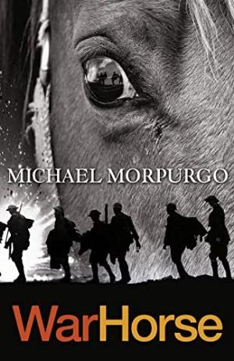  War Game: Village Green to No Man’s Land  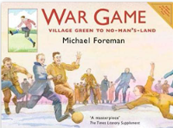  Guided reading – Vlad and the First World War  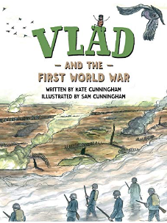  Where the Poppies Now Grow  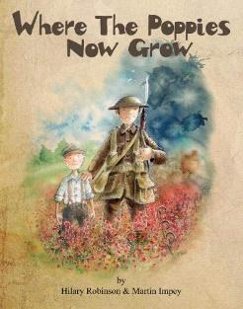  Oranges in No Man’s Land  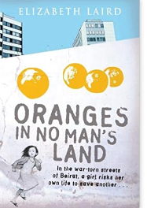 | Mary and the Riddle of the Sphinx  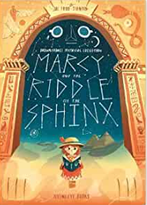  What a Waste  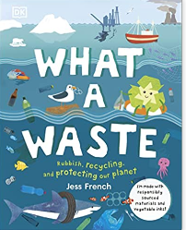  Guided reading  Climate Rebels, How to Change the World  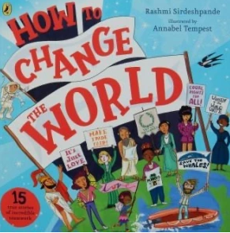  Class reader – A Mummy Ate My Homework  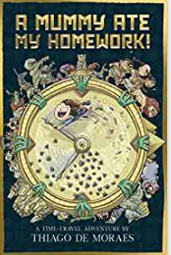 | Boy 87  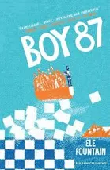  Guided reading –  Viking Voyagers  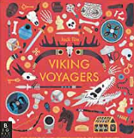  A Children’s Introduction to Norse Mythology  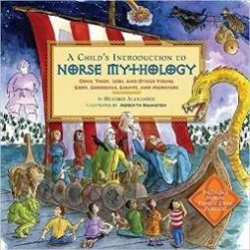  Class reader  There’s a Boy in the Girls Bathroom  
Maths | Chapter 1 - Numbers to 10 million  Chapter 2 – Four operations on whole numbers  Chapter 3 - Fractions | Chapter 4 – Decimals  Chapter 5 - Measurements  Chapter 6 – Word Problems  Chapter 7 – Percentage  Chapter 8 – Ratio  Chapter 9 – Algebra  Chapter 12- Geometry  Chapter 10 – Area and Perimeter  Chapter 11 – Volume | Chapter 14 – Graphs and Averages  Chapter 15 - Negative numbers  Chapter 13- Position and Movement  SATs revision  Reasoning investigations
Computing | Computer Science  Information Literacy  Online Safety | Media  Data Handling  Online Safety | Computer Science  Media  Online Safety
P.E | Netball  Gymnastics | Dance  OAA | Athletics  Rounders
Art | Great artists, architects and designers.-  Artist -Richard Eurich  Europe  Sketches | Hieroglyphs, clay masks and pots | Weaving
DT | Anderson shelters | Burglar alarms | Lasagne
History | Aspect of National History  WW1 and WW2 | Ancient Egypt | British Settlement History  Study into Anglo Saxons and Vikings
Geography | Countries of the world involved in the wars | Physical geography – canals &reservoirs  Rivers and water cycle – The Journey of water  Pollution | Rivers and Maps  Human Geography – settlement and land use
Spanish | Recap on greetings, pets, numbers 0 -50  Recap on days of the week & months of the year  Homes and Rooms  Christmas Spanish songs | Ingredients for Spanish desserts  Weather  Weather phrases and seasons | Recap on directions/asking where places are  Saying where you live  Role play and simple conversations using all that has been learned
Musical Tuition | Guitar | Guitar | Guitar
Music | Autumn 1 – Happy  Autumn 2 – Classroom Jazz | Spring 1 – A New Year Carol  Spring 2 – You’ve Got A Friend | Summer 1 – Music and Me  Summer 2 – Reflect, Rewind, Replay
Experiences | Now Press Play – World War 2 | *Rethink food (Spring 1)  Now Press Play – water cycle, climate change, ancient Egypt, Forces, recycling | Now Press Play – Vikings, rainforests, evolution
Opportunities for Outdoor Learning | Making bow and arrows  Gardening  Remembrance day service  Eden Camp | Gardening  Ilkley trip rivers | Gardening  Jorvic Viking Centre
Opportunities for Aspirations | Women in the War  Community champions visit  Winston Churchill  Norman Tennant (artist)  Catherine Black (nurse) | Community champions visit  Tutankhamun  Cleopatra  Claude Monet (artist)  Ruth Ella Moore (micro biologist) | Community champions visit  Alfred the Great  Charles Darwin  Jorvik Viking centre
Healthy Lifestyles/Nutrition | War diet vs modern diet  gardening | gardening | gardening

