COOP ACADEMY PENNY OAKS
LONG TERM PLANNING – Yr 4
 | Autumn | Spring | Summer
Topic | Our Magical City | The Great Fire of London | The Great Escape
R.E | Aut 1 : Judaism – Beliefs and practices  Aut 2 : Christianity – Christmas/ Incarnation | Spr 1: Judaism – Passover  Spr 2: Christianity – Easter/ Salvation | Sum 1: Judaism- Rites of Passage and good works  Sum 2: Christianity – Prayer and worship
Oracy opportunities | Skills: active listening, taking turns, sharing ideas, building on, sensing the room, joining in  Roles: Observer, Scribe | Skills: inviting others, making notes, using speech bubbles, asking questions, agreeing and disagreeing  Roles: Challenger, Reporter | Oracy games:  ABCD  Line of agreement  Snowballing  True or false
Science | States of Matter | Electricity  Living things and their habitats | Animals including humans  Sound
PSHE/RSE | Coop Values - Democracy, Voting (Pioneers)  To value the different contributions that people and groups make to the community.  Story Project - Autumn 1 - The Grand Hotel of Feelings  Autumn 2 - Penguin Pig | Story Project -  Spring 1 - The Proudest Blue  Spring 2 - This Moose Belongs to Me | Story Project -  Summer 1 - The Tunnel  Summer 2 - Mama Miti
English Texts | Aut 1:  English: Oliver Twist – Charles Dickins  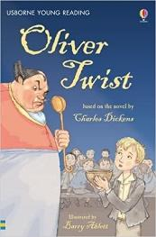  English: Oliver Twist – Charles Dickins  Guided Reading: Leather Shoe Charlie  Class Reader: The Secret History of Tom Trueheart by Ian Beck  Aut 2:  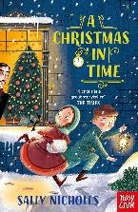  English: A Christmas in time by Sally Nicholls  Guided Reading: The Rhythm of the Rain  Class Reader: Alex Neptune: Dragon thief by David Owen | 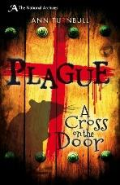  Spr 1:  English: Plague (National Archives) by Ann Turnbull  Guided Reading: Plague: A History of Pestilence and Pandemics  Class Reader: The girl who walked on air by Emma Carroll  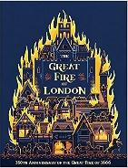  Spr 2:  English: The Great Fire of London by Emma Adams  Guided Reading: The Great Fire: A City of Flames  Class Reader: Shipwrecked by Jenny Pearson | 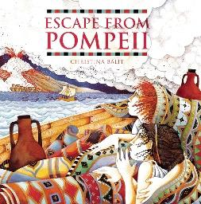  Sum 1:  English: Escape from Pompeii by Christina Balit  Guided Reading: How things happen in the Natural World  Class Reader: Journey to the river sea by Eva Ibbotson  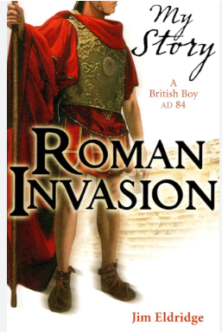  Sum 2:  English: Roman Invasion by Jim Eldridge  Guided Reading: You Wouldn’t want to be a Roman Solider  Class Reader: Journey to the river sea by Eva Ibbotson
Maths | Chapter 1 - Numbers to 10,000  Chapter 2 - Addition and Subtraction within 10,000  Chapter 12 - Geometry - property of shapes  Chapter 3 - Multiplication and Division | Chapter 3 - Further Multiplication and Division continued  Chapter 7 - Measurement - time  Chapter 4 - Calculations: Further Multiplication and Division continued  Chapter 11 - Measurement - Area and Perimeter of figures  Chapter 8 - Fractions, Decimals  Chapter 9 - Money | Chapter 9 - Measurement - Money continued  Chapter 10 - Measurement - Mass/ Volume/ Length  Chapter 6 – Fractions  Chapter 13 - Position & Movement  Chapter 14 - Roman Numerals  Chapter 5 - Statistics - Graphs
Computing | Computer Science  Information Literacy  Online Safety | Media  Data Handling  Online Safety | Computer Science  Media  Online Safety
P.E | Hockey  Gymnastics | Dance  OAA | Cricket  Athletics
Art | Well known Artist – David Hockney | Paul Klee abstract art | Michael Angelo – pastels, sculpture  Mosaics
DT | Making a mascot pneumatics | Make an electrical switch | Jewellery from plastic bags/plastic
History | Saltaire/ local history | The Great Fire of London | Romans – Impact on Britain, Romanisation of Britain
Geography | Local Settlements/land use  Canals/Saltaire | 17th Century - The Plague/The Great Fire of London (Bridges/Canals/houses) | Rome – city in Europe, compare and contrast with Bradford, Volcanoes
Spanish | Welcome to school (Recap core language, rooms in a school, classroom objects)  My town, your town (Commands, shops, asking and giving directions) | Alien family (Epiphany, family members, personal info, face parts and numbers)  Moving our bodies (Face and body parts nouns and commands, yoga with bo | At the doctors and jungle animals (Aches and pains, doctor role play, animal nouns, adjectives, simple sentences, story)  Summertime (Weather phrases, seasons, forecast, ice cream flavours, opinions, ordering politely, roleplay)
Music Tuition | Ukulele  Choir singing with Mr Perkinton | Ukulele  Choir singing with Mr Perkinton | Ukulele  Choir singing with Mr Perkinton
Music | improvise and compose music for a range of purposes using the inter-related dimensions of music  listen with attention to detail and recall sounds with increasing aural memory | play and perform in solo and ensemble contexts, using their voices and playing musical instruments with increasing accuracy, fluency, control and expression | use and understand staff and other musical notations
Experiences | History - Now Press Play Victorian Britain  Art – seeing the arrival of spring at Salts Mill  History – visiting Saltaire village | History - Now Press Play – Great Fire of London | Rethink food Summer 1  SDG – industry, innovation and infrastructure, decent work and economic growth, Reduced inequalities.  History - Now Press Play – Roman Britain
Opportunities for Outdoor Learning | History - Visit Saltaire – walking tour  Science – making solids, liquids and gases | Science – classifying minibeast in school grounds  History - Bolling Hall – Great fire of London workshop | History - Murton Park – Roman day
Opportunities for Aspirations | PSHE – jobs public services  Art– local artist from Yorkshire  Spanish – learn another language  Music - become a singer/musician | DT – jobs designer/engineer  History – job fight fighter to teach how to put out fires  Spanish – learn another language | PHSE – environmentalist  Spanish – learn another language  Music –become a ukulelist
Opportunities for Healthy Lifestyles/Nutrition | History - Nutrition cooking lessons – making food from the Victorian era  PE - Healthy lifestyles – physical, active lesson  PSHE - having a balanced diet | PE - Healthy lifestyles – physical, active lesson | Nutrition lessons – making food from the Romans  PE - Healthy lifestyles – physical, active lesson  Science – looking after teeth

