Coop Academy Penny Oaks
LONG TERM PLANNING - Year 1
 | Autumn |  | Spring |  | Summer
Topic | Castles |  | Eco-Warriors |  | Incredible India
R.E
Science | Materials |  | Animals including humans |  | Plants
 | Seasonal Changes
PSHE/RSE | What helps keep bodies healthy;  Hygiene routines  Keeping safe around household products; how to ask for help if worried. |  | We meet God’s love in our family |  | Looking after the environment  Where money comes from; how to use money; saving and spending money
English  texts | Autumn 1  Non-Fiction- Letter Writing  King Leonard’s Teddy by Phoebe Swan  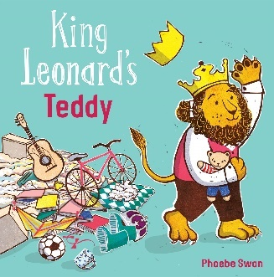  Fiction- Adventure Story  The Worst Princess by Anna Kemp  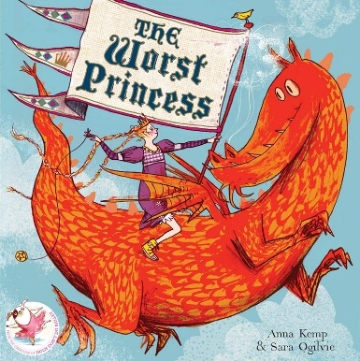  Poetry: Dragan poems and Blackout Poetry  Autumn 2  Fiction-  The King who Banned the Dark by Emily Haworth-Booth  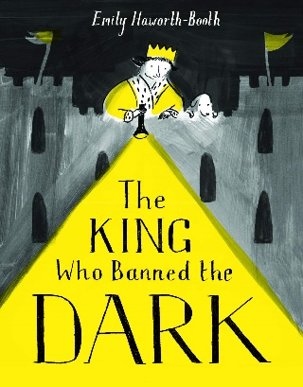  Non-Fiction- Information text  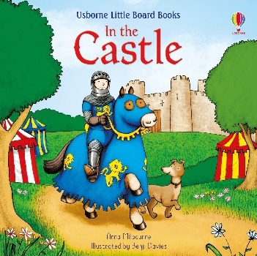  Poetry: Coming Home – Michael Morpurgo  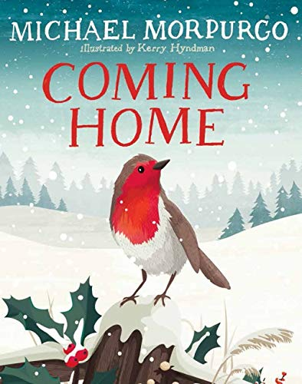  Class Reader: King Arthur and the Knights of the Round Table by Marcia Williams.  Rupunzel by Stephanie Stansbie  Little Red by Bethan Woollvin |  | Spring 1  Fiction- Diary Entry  Dear Earth by Isabell Otter  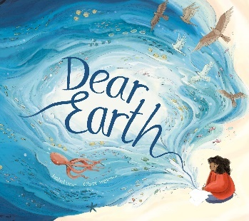  Non- Fiction- Information Text  Somebody Swallowed Stanley  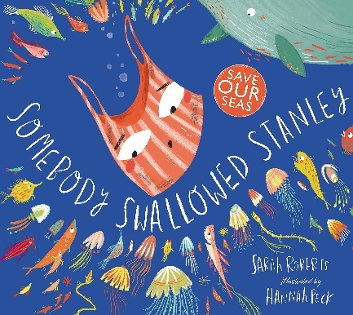  Poetry- I am the Seed That Grew the Tree  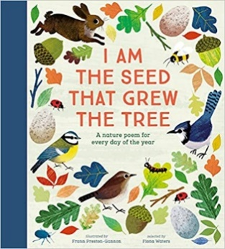  Spring 2  Fiction- Adventure Story  The Secret of the Black Rock by Joe Stanton  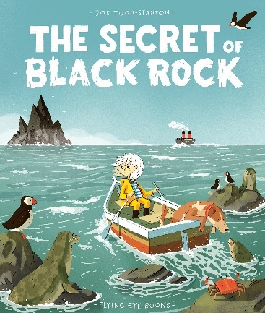  Non- Fiction- Instruction Writing  How to save a Whale  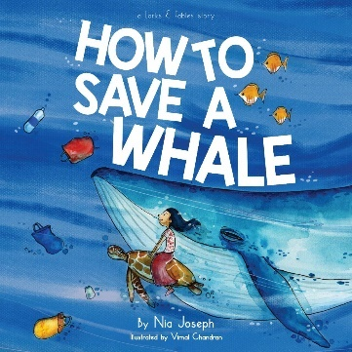  Class Reader: The Jungle Book  Charlottes Web by EB White Stuart |  | Summer 1  Fiction- Lost and Found  August Lost his Smile by Catherine Rayner  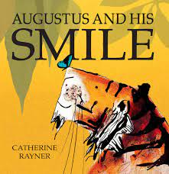  Poetry- I am the Seed That Grew the Tree  Summer 2  Non-Fiction- Recount  Recount of a trip to Topical World.  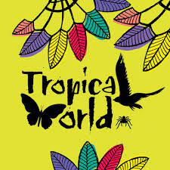  Fiction- Stories about habitats  Tad by Benji Davies  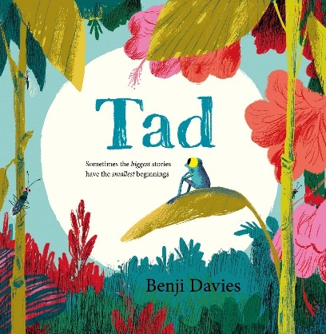  Class Reader: Evie and the Animals by Matt Haig
Maths | Numbers to 10  Number Bonds  Addition Within 10  Subtraction Within 10  Positions  Numbers to 20  Addition and Subtraction Within 20 |  | Shapes and Patterns  Length and Height  Numbers to 40  Addition and Subtraction Word Problems  Multiplication  Division |  | Fractions  Numbers to 100  Time  Money  Volume and Capacity  Mass  Space
Cross Curricular  Maths | Create a timeline on Queen Elizabeth’s life.  Counting the number of people working in castles.  Looking at shapes of castles. |  | Measure how much plants have grown in spring  Reading graphs on the growth of plants. |  | Measuring when cooking.  Comparing temperatures in India and the UK.
Computing | Computer Science  Information Literacy  Online Safety |  | Media  Data Handling  Online Safety |  | Computer Science  Media  Online Safety
P.E | Football | Gymnastics | Dance | Basketball | Cricket | Athletics
Art | Portraits of Queen Elizabeth and self-portraits.  Castles-brick effect, collages  Wax crayons dragons-water colours  Charcoal towers |  | Clay whales  Sea collage  Plasticine sea creatures  Wax crayons whales  Seascape in Van Gogh’s style (paintbrush techniques)  3D sea turtles and jellyfish made from recycled materials. |  | Indian landscapes, cityscape  Animal patterns (tigers, peacock)  Tie dye (shebori)  Jungle  Swapna Augustine
DT | Design and create a working drawbridge.  Cooking a Royal Feast |  | Design and make an upcycled fabric bag  Healthy Eating |  | Design and sew an Indian dress for our class puppets.  Cooking with Parents
History | Who lives in a castle? |  | The Invention of Plastic |  | Gandhi’s campaign for Independence
Geography | The United Kingdom |  | What does Earth look like from space? |  | Comparing Goa to Bradford
Music Tuition | Recorders |  | Recorders |  | Recorders
Music | Hey You!  Rhythm in the Way we Walk and Banana Rap |  | The Groove  Round and Round |  | Your Imagination  Reflect, Rewind and Replay
Experiences | Fire Safety talk  Planting and gardening- Planting an orchid in school grounds.  Planting a tree at home and looking after it.  Rethink food |  | Think about where food comes from. |  | Indian culture day- Parents visiting, discuss culture and prepare Indian food.  Tropical animals visit in school.  Holi festival  Finance talk
Opportunities for Outdoor Learning | Planting and gardening- Planting an orchid in school grounds. Planting a tree at home and looking after it.  Fieldwork  QR hunt |  | Gardening  Safe planet posters |  | Visit local temple  Holi festival
Opportunities for  Aspirations | Mrs Khambhaita talk to pupils about being a headteacher.  Train safety talk |  | Donating food to the local homeless shelters. |  | Visit to the Local temple  Visit from secondary school pupils to create artwork.
Healthy Lifestyles/  Nutrition | Autumn walk  Experience riding a train  Healthy eating with Mrs Garner |  | Spring Walk |  | Cooking for culture day
Trips | Skipton Castle |  | The Deep |  | Tropical world  Visit to the local temple.

