St Mary’s & St Peter’s Catholic Primary School
LONG TERM PLANNING (Cycle B)– Year 1
 | Autumn |  | Spring |  | Summer
Topic | Castles |  | Eco-Warriors |  | Incredible India
R.E | Christianity |  | Christianity |  | Judaism
Science | Materials |  | Animals including humans |  | Plants
 | Seasonal Changes
PSHE/RSE | Co op Values  My Happy Minds  Meet the Brain  Story Project  The Friendship Bench by Wendy  Meddour  Angry Arthur by Hiawyn Oram |  | My Happy Minds  Celebrate  Appreciate  Story Project  Look Up by Nathan Byron  Morris the Mankiest Monster by Giles  Andreae |  | My Happy Minds  Relate  Engage  Story Project  Peace at Last by Jill Murphy  My Big Fantastic Family by Charlotte and  Adam Guillane
Values | Kindness  Love of Learning  Self-Control  Compassion |  | Forgiveness  Reflection  Confidence  Patience |  | Honesty  Respect  Determination  Generosity
English  texts | Autumn 1  Non-Fiction- Letter Writing  King Leonard’s Teddy by Phoebe Swan  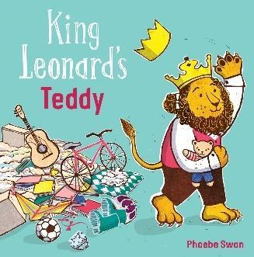  Fiction- Adventure Story  The Worst Princess by Anna Kemp  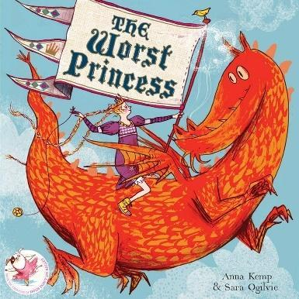  Poetry: Dragan poems and Blackout Poetry  Autumn 2  Fiction-  The King who Banned the Dark by Emily Haworth-Booth  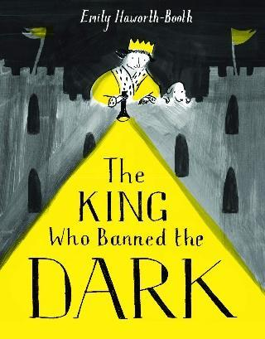  Non-Fiction- Information text  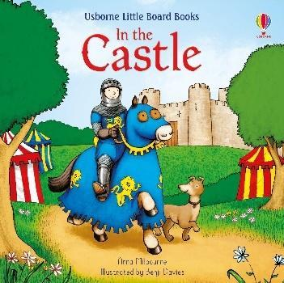  Poetry: Coming Home – Michael Morpurgo  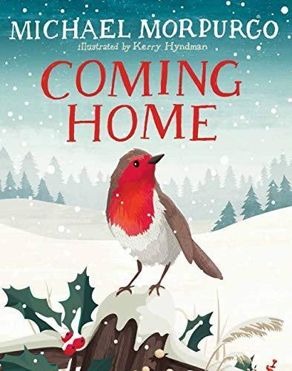  Class Reader: King Arthur and the Knights of the Round Table by Marcia Williams.  Rupunzel by Stephanie Stansbie  Little Red by Bethan Woollvin |  | Spring 1  Fiction- Diary Entry  Dear Earth by Isabell Otter  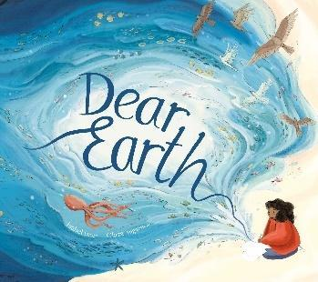  Non- Fiction- Information Text  Somebody Swallowed Stanley  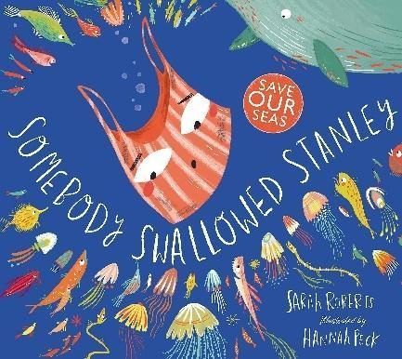  Poetry- I am the Seed That Grew the Tree  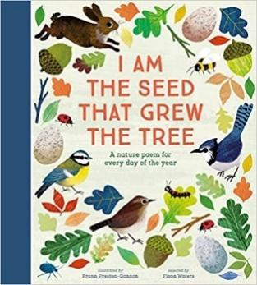  Spring 2  Fiction- Adventure Story  The Secret of the Black Rock by Joe Stanton  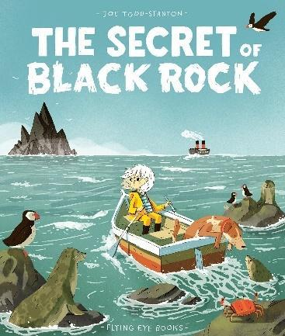  Non- Fiction- Instruction Writing  How to save a Whale  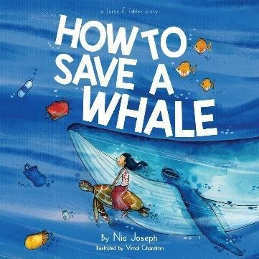  Class Reader: The Jungle Book  Charlottes Web by EB White Stuart |  | Summer 1  Fiction- Lost and Found  August Lost his Smile by Catherine Rayner  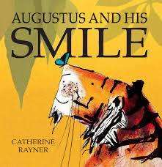  Poetry- I am the Seed That Grew the Tree  Summer 2  Non-Fiction- Recount  Recount of a trip to Topical World.  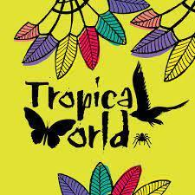  Fiction- Stories about habitats  Tad by Benji Davies  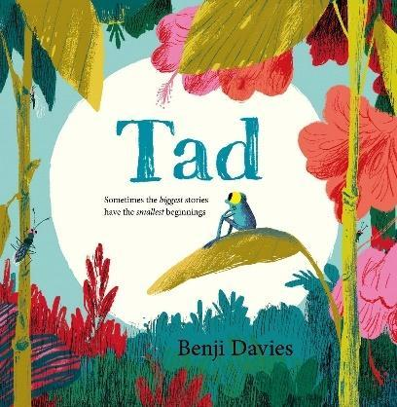  Class Reader: Evie and the Animals by Matt Haig
Maths | Numbers and Place Value  Number Bonds  Calculations: Addition and Subtraction within 10  Geometry- Properties of Shapes: Shapes and Patterns  Number and Place Value: Numbers to 20  Calculations: Addition and Subtraction within 20 |  | Calculations: Addition and Subtraction Word Problems  Fractions  Measurement: Time  Number and Place Value: Numbers to 40  Geometry- Position and Direction: Positions  Measurement: Length and Height |  | Calculations: Multiplication  Calculations: Division  Measurement: Mass  Measurement: Volume and Capacity  Measurement: Money  Geometry- Position and Direction: Space
Cross Curricular  Maths | Counting the number of people working in castles.  Looking at the shapes of castles. |  | Measuring in Cooking |  | Measure how much plants have grown in spring  Reading graphs on the growth of plants.  Comparing temperatures in India and the UK.
Computing | Computer Science  Digital Literacy |  | Media  Data Handling |  | Computer Science  Media
P.E | Games- Attack, Defend, Shoot | Gymnastics | Dance | Games- Send, Return, Net, Wall | Games- Hit, Catch, Run | Athletics- Run, Jump, Throw
Art | Exploring mark making and lines (stamps  ink work printing) |  | Seascapes  Van Gogh |  | Animal patterns Swapna  Augustine Plasticine (sculpture)
DT | Sliders and Levers  Making moving Cards  Cooking a Royal feast |  | Fruit Kebabs |  | Making Hand Puppets
History | Who lives in a castle? |  | The Invention of Plastic |  | Gandhi’s campaign for Independence
Geography | The United Kingdom |  | What does Earth look like from space? |  | Comparing Goa to Bradford
Music Tuition | Singing Lessons |  | Singing Lessons |  | Singing Lessons
Music | Composer- Mozart, Rondo alla Turca (Classical period)  Popular music-  Kate Bush- Wildman (Art pop) |  | Composer- Mozart, Rondo alla Turca (Classical period)  Popular music-  Kate Bush- Wildman (Art pop) |  | Musical traditions- Brazil, Samba – Fanfarra (Cabua- Le-Le)- Sergio Mendes/ Carlinhos Brown.
Experiences | Visit Skipton Castle  English Heritage |  | Think about where food comes from.  Playing with old toys |  | Indian culture day- Parents visiting, discuss culture and prepare Indian food.  Tropical animals visit in school.  Holi festival
Opportunities for Outdoor Learning | Train Experience  Fieldwork  QR hunt |  | Gardening  Safe planet posters |  | Visit local temple  Holi festival  Gardening
Opportunities for  Aspirations | Train safety talk |  | Donating food to the local homeless shelters.  Adopt an animal |  | Visit to the Local temple
Healthy Lifestyles/  Nutrition | Autumn walk  Experience riding a train  Healthy eating with Mrs Garner |  | Spring Walk |  | Cooking for culture day
Trips | Skipton Castle |  | The Deep  National Science Museum |  | Tropical world  Visit to the local temple.

