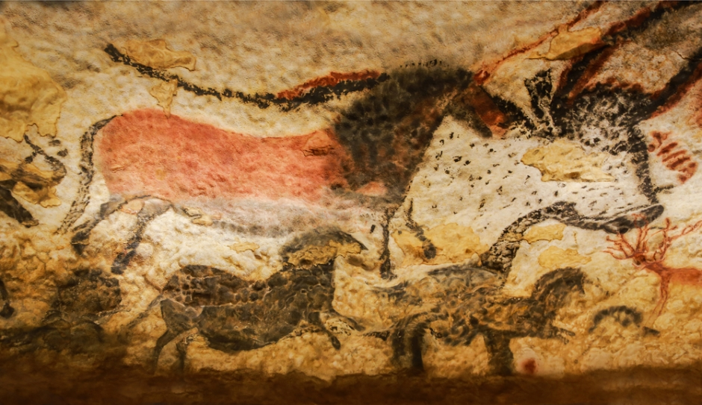

**Year 3 Autumn 1**

**The Stone Age**

**Science**

**Plants**

**National Curriculum:**

* Identify and describe the functions of different parts of flowering plants: roots, stem/trunk, leaves and flowers ·
* Explore the requirements of plants for life and growth (air, light, water, nutrients from soil, and room to grow) and how they vary from plant to plant

**Progression in Skills:**

* Identify and describe the functions of different parts of flowering plants: roots, stem/trunk, leaves and flowers
* Explore the requirements of plants for life and growth (air, light, water, nutrients from soil, and room to grow) and how they vary from plant to plant

**English**

**English Texts:**   
  
**The First Drawing**,by Mordicai Gerstein

**Stone Girl, Bone Girl: The Story of Mary Anning**, by Laurence Anholt

**Year 3 Writing Assessment Objectives:**

* write for both fictional and non-fictional purposes, drawing on their reading to inform the vocabulary and grammar of their writing
* know the difference between a statement, question, exclamation and command
* use present and past tense verb forms, mostly correctly and consistently
* use adverbs to express time
* maintain Standard English forms, e.g. using a/an correctly
* use a range of co-ordinating and subordinating conjunctions
* use simple organisational devices (e.g. headings or sub-headings) appropriately
* spell most words correctly, adding prefixes and suffixes appropriately, spelling the correct form of homophones and spelling all common exception words correctly (KS1 and Y3)
* use the diagonal and horizontal strokes needed to join some letters
* make simple additions, revisions and proof-reading corrections to their own writing

**Maths**

**Chapter 1:** Numbers to 1000

Counting in Hundreds  
Counting in Hundreds, Tens and Ones  
Place Value  
Comparing and Ordering Numbers  
Counting in Fifties  
Number Patterns  
Counting in Fours and Eights

**Chapter 2:** Addition and Subtraction

Addition and Subtraction Facts  
Adding Ones  
Adding Tens  
Adding Hundreds  
Simple Adding  
Adding with Renaming   
Subtracting Ones  
Subtracting Tens  
Subtracting Hundreds  
Simple Subtracting  
Subtracting with Renaming  
Using Models

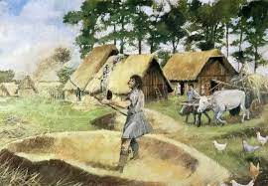

**History**

**Stone Age to Iron Age**

**National Curriculum:**

Changes in Britain from the Stone Age to the Iron Age

**Progression in Skills:**

* Place the time studied on a time line
* Use dates and terms related to the study unit and passing of time
* Sequence several events or artefacts
* Find out about every day lives of people in time studied
* Identify reasons for and results of people's actions
* Understand why people may have wanted to do something
* Look at representations of the period – museum, cartoons etc
* Use a range of sources to find out about a period
* Observe small details – artefacts, pictures
* Select and record information relevant to the study
* Communicate their knowledge through:   
  -Discussion….   
  -Drawing pictures…   
  -Drama/role play..   
  -Making models…..   
  -Writing..

**Oracy**

**National Curriculum:**

* Listen and respond appropriately to adults and their peers
* Ask relevant questions to extend their understanding and knowledge
* Use relevant strategies to build their vocabulary
* Articulate and justify answers, arguments and opinions

**Progression in Skills:**

* Be able to listen to complex information and work out most of the key information (some support may be required to help them to work out the next steps) e.g. ‘Tell your partner three facts about ... using the right words if you can and then write them down.’
* Recognise the cause and effect element of spoken instructions, that there may be consequences if certain instructions are not followed e.g. ‘Everyone needs to stop talking and listen now, otherwise we will be late for break.’
* Ask a range of different types of questions to find out specific information including ‘how’ and ‘why’ e.g. ‘How do we know this was from Ancient Roman times?’
* Be aware of when they haven’t understood something because of the vocabulary used and ask a general clarification question e.g. ‘What does that long word mean?’
* Experiment with new vocabulary in different contexts to test out understanding and to learn from mistakes e.g. ‘The land around the arctic has no trees and is called the tundrum.’ (Meaning ‘tundra’)
* Give reasons and explanations for choices and viewpoints in class discussions e.g. ‘I think the ending of the book is better than the ending in the film because sometimes things don’t work out well for people in real life.’



**Spanish**

**A New Start**

Greetings, feelings, numbers to 10 & colours

**National Curriculum:**

* listen attentively to spoken language and show understanding by joining in and responding
* explore the patterns and sounds of language through songs and rhymes and link the spelling, sound and meaning of words
* engage in conversations; ask and answer questions; express opinions and respond to those of others; seek clarification and help
* speak in sentences, using familiar vocabulary, phrases and basic language structures
* develop accurate pronunciation and intonation so that others understand when they are reading aloud or using familiar words and phrases
* appreciate stories, songs, poems and rhymes in the language
* broaden their vocabulary and develop their ability to understand new words that are introduced into familiar written material, including through using a dictionary
* describe people, places, things and actions orally and in writing
* understand basic grammar appropriate to the language being studied, including (where relevant): feminine, masculine and neuter forms and the conjugation of high-frequency verbs; key features and patterns of the language; how to apply these, for instance, to build sentences; and how these differ from or are similar to English.

**Progression in Skills:**

* Can say a greeting
* Can respond to a question about feelings and name
* Can attempt a question about name and feelings
* Can remember and say most numbers from 1 to 10
* Can say at least four colours

**Art**

**National Curriculum:**

* Pupils should be taught to develop their techniques, including their control and their use of materials, with creativity, experimentation and an increasing awareness of different kinds of art, craft and design.
* Pupils should be taught: to improve their mastery of art and design techniques, including drawing, painting and sculpture with a range of materials [for example, pencil, charcoal, paint, clay]
* about great artists, architects and designers in history

**Progression in Skills:**

* Select and record from first hand observation, experience and imagination, and explore ideas for different purposes.
* Mix a variety of colours and know which primary colours make secondary colours.
* Use a developed colour vocabulary
* Experiment with different effects and textures inc. blocking in colour, washes, thickened paint etc.
* Work confidently on a range of scales e.g. thin brush on small picture etc.
* Explore the roles and purposes of artists, craftspeople and designers working in different times and cultures.
* Use different media to achieve variations in line, texture, tone, colour, shape and pattern.
* Experiment with a range of media e.g. overlapping, layering etc.
* Compare ideas, methods and approaches in their own and others’ work and say what they think and feel about them.
* Question and make thoughtful observations about starting points and select ideas to use in their work.

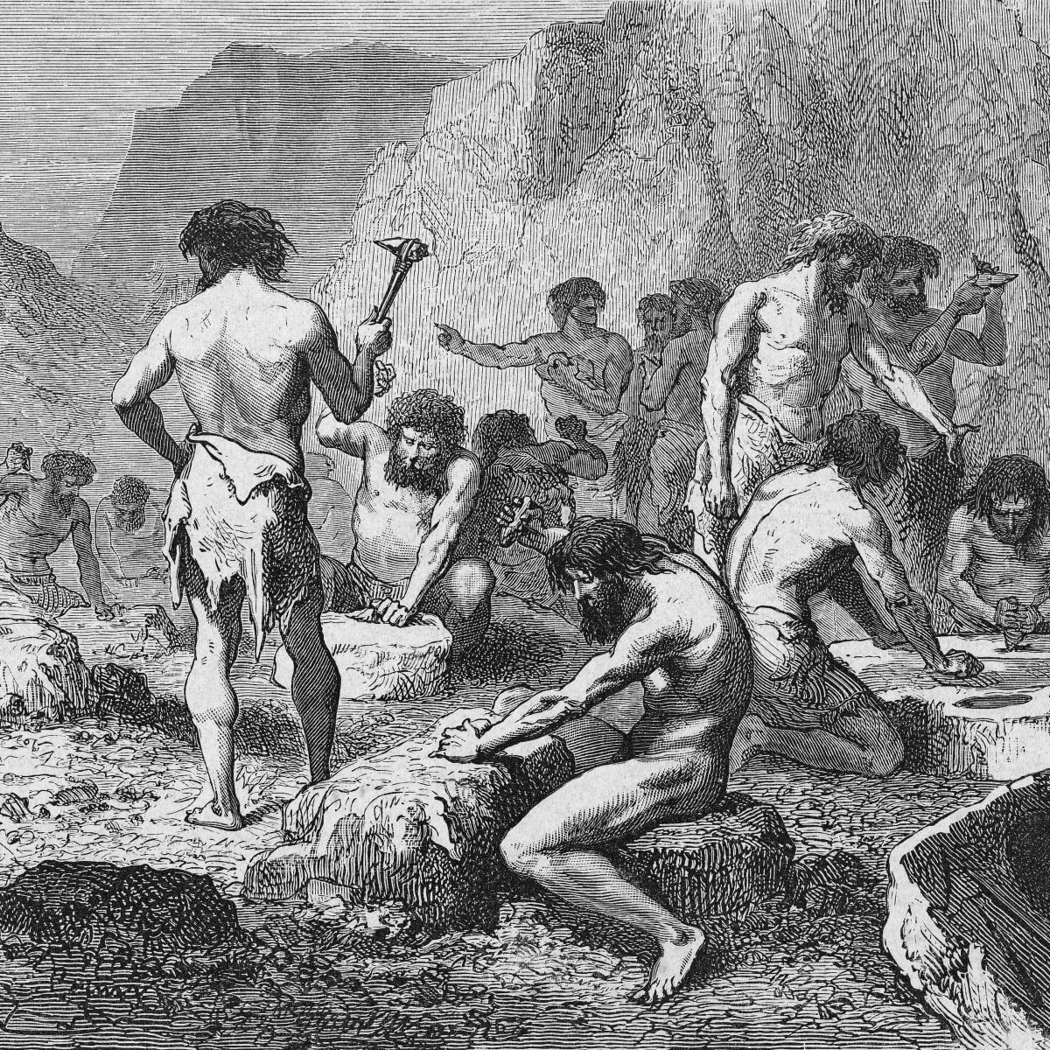

**P.E**

**Hockey & Football**

**National Curriculum:**

* Pupils should continue to apply and develop a broader range of skills, learning how to use them in different ways and to link them to make actions and sequences of movement. They should enjoy communicating, collaborating and competing with each other. They should develop an understanding of how to improve in different physical activities and sports and learn how to evaluate and recognise their own success.
* Pupils should be taught to: Use running, jumping, throwing and catching in isolation and in combination
* Play competitive games, modified where appropriate [for example, badminton, basketball, cricket, football, hockey, netball, rounders and tennis], and apply basic principles suitable for attacking and defending
* Compare their performances with previous ones and demonstrate improvement to achieve their personal best

**Progression in Skills:**

* Recognise key features of a hockey stick, including how to hold it and use the flat side
* Play using basic hockey rules
* Send the ball in isolation and in a game
* Can show a defensive tackling position
* Receive a ball with some consistency
* Stop and control the ball and move into dribble
* Work the feet around the ball to avoid kicking it
* Work as a team to score points
* Show support, encouragement and sportsmanship

**Computing**

**Computer Science**

**National Curriculum:**

* Write and debug programs that accomplish specific goals, including controlling or simulating physical systems; solve problems by decomposing them into smaller parts.
* Use logical reasoning to explain how some simple algorithms work and to detect and correct errors in algorithms and programs.

**Progression in Skills:**

* Create a simple program using one input
* Create a program using input and output devices

**Computing**

**Computer Science**

**National Curriculum:**

* Write and debug programs that accomplish specific goals, including controlling or simulating physical systems; solve problems by decomposing them into smaller parts.
* Use logical reasoning to explain how some simple algorithms work and to detect and correct errors in algorithms and programs.

**Progression in Skills:**

* Create a simple program using one input
* Create a program using input and output devices



**PHSE**

**The Story Project  
On a Magical Do Nothing Day** by Beatrice Allemagne

* I can tell you how nature benefits my well being.
* I can explain why it is important to respect the rights of all living things.
* I can explain the importance of having a balance between online games and other hobbies.
* I can tell you how I can keep safe when I am outside.
* I can tell you some strategies I have for managing disappointment.

**Progression in Skills:**

* How to respond safely and appropriately to adults they may encounter (in all contexts, including online) whom they do not know.
* About the benefits of rationing time spent online, the risks of excessive time Spent on electronic devices and the impact of positive and negative content online on their own and others’ mental and physical wellbeing.
* How people and other living things have different needs; about the responsibilities of caring for them.

**PHSE**

**Co-op Values**Self responsibility, setting up shop  
  
To know:

* What does responsibility for self and others mean and how do we show this?
* How did the Pioneers start on the journey of self responsibility?

To feel:

* Understanding the impact of taking responsibility for self and others
* Understand how people can shape identity and contributes to positive society

To do:

* People and Places - Visit a local Co-op shop and invite the local manager to talk about self responsibility and how they show this individually and collectively.
* People and Places - Create job descriptions, interview process and accompanying questions.
* Problem - No food bank (learning pit and fictional narrative) how can we stop this?
* Application of knowledge/skill - Set up a Co-op shop or food bank in school

**Progression in Skills:**

* L3: about the relationship between rights and responsibilities
* L4: the importance of having compassion towards others; shared responsibilities we all have for caring for other people and living things; how to show care and concern for others



**Music**

**National Curriculum:**

* Play and perform in solo and ensemble contexts, using their voices and playing musical instruments with increasing accuracy, fluency, control and expression.
* Improvise and compose music for a range of purposes using the inter-related dimensions of music.
* Listen with attention to detail and recall sounds with increasing aural memory.
* Use and understand staff and other musical notations.
* Appreciate and understand a wide range of high-quality live and recorded music drawn from different traditions and from great composers and musicians.
* Develop an understanding of the history of music.

**Progression in Skills:**

* Pupils will explore how music has developed through different periods, styles and cultures in regards to –
* Pulse
* Tempo
* Rhythm
* Dynamics
* Pitch
* Texture
* Pupils will be able to constructively express their thoughts on performances including peer feedback developing listening skills and musical vocabulary.

**Computing**

**Computer Science**

**National Curriculum:**

* Write and debug programs that accomplish specific goals, including controlling or simulating physical systems; solve problems by decomposing them into smaller parts.
* Use logical reasoning to explain how some simple algorithms work and to detect and correct errors in algorithms and programs.

**Progression in Skills:**

* Create a simple program using one input
* Create a program using input and output devices

**RE**

**Divali**

* I can tell you three important actions I could take to support a group I belong to. I can discuss my understanding of my group’s symbol
* I can describe some of the ways Hindus celebrate Divali and start to explain how I think Hindu children might feel at Divali
* I can start to say why Divali might bring a sense of belonging to Hindus.