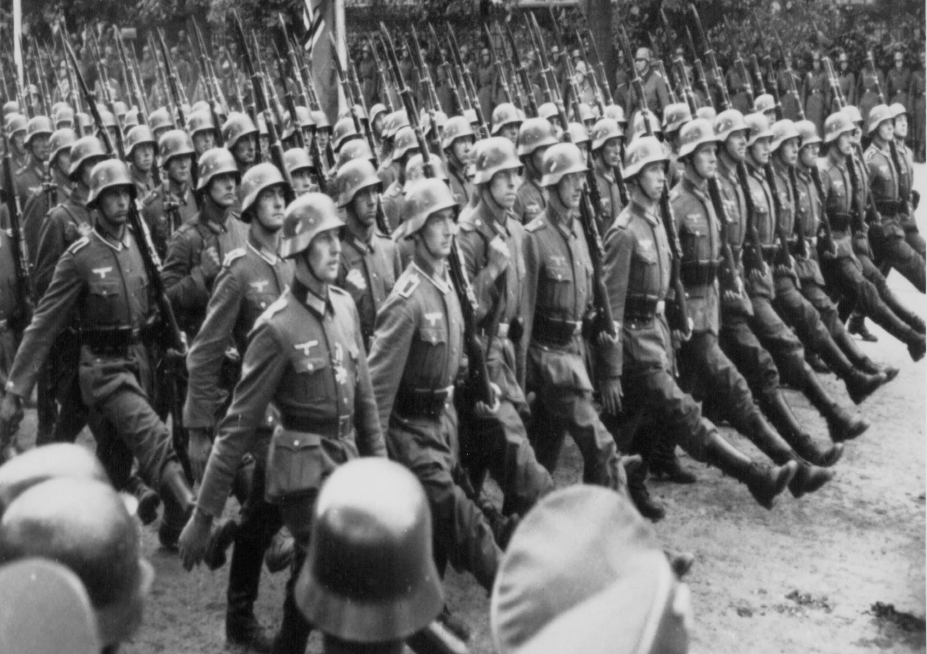

**Fighting Fit Aut 1**

**Maths**

Chapter 1 - Numbers to 10 million

Chapter 2 – Four operations on whole numbers

Chapter 3 - Fractions

**English**

English – War Horse

Guided reading –, Survivors, A Christmas Truce

Class reader –Oranges in No Man’s Land

We will write effectively for a range of purposes and audiences, selecting language that shows good awareness of the reader (e.g. the use of the first person in a diary; direct address in instructions and persuasive writing), using similar writing as a model (WAGOLL and other texts)

In narratives we will describe settings, characters and atmosphere, using a variety of techniques to engage the reader and choosing appropriate vocabulary that creates a consistent picture, e.g. verbs, preposition phrases, fronted adverbials, expanded noun phrases, relative clauses.

We will also build upon the skills to integrate dialogue in narratives to convey character and advance the action, using correctly punctuated speech

**History**

**N/C Pupils should continue to**

**Develop a chronologically secure knowledge and understanding of British, local and world history, establishing clear narratives within and across the periods they study.**

• Find out about beliefs, behaviour and characteristics of people, recognising that not everyone shares the same views and feelings

• Compare beliefs and behaviour with another time studied

• Write another explanation of a past event in terms of cause and effect using evidence to support and illustrate their explanation

• Know key dates, characters and events of time studied• Link sources and work out how conclusions were arrived at

• Consider ways of checking the accuracy of interpretations – fact or fiction and opinion

• Be aware that different evidence will lead to different conclusions

• Confidently use the library and internet for research



**Art and DT**

Pupils should be taught to develop their techniques, including their control and their use of materials, with creativity, experimentation and an increasing awareness of different kinds of art, craft and design. To improve their mastery of art and design techniques, including drawing, painting and sculpture with a range of materials ,for example, pencil, charcoal, paint, clay and about great artists, architects and designers in history (Richard Urich local WW1 artist

• Describe varied techniques.

• Be familiar with layering prints.

• Be confident with printing on paper and fabric.

• Alter and modify work.

• Work relatively independently

**RE**

The Kingdom of God

Reflect on what the Kingdom of God is like

Reflect on the importance of responding to the invitation to the kingdom.

Know that everyone is called to enter

Reflect on what commitment is needed to enter the Kingdom

**PSHE**

Co-op Ways of Being:

Understanding the impact of the following and how they impact and influence Coop Communities way of being.

Solidarity

Self-Help

Democracy

Equality

Equity

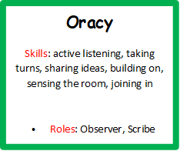 

**Spanish**

Revise greetings, asking how you are feeling and responding

Read and revise 0-10, and extend with numbers 11-20

Understand and respond to the question ¿Cómo te llamas? (What is your name?)

Understand and respond to the question: ¿Cuántos años tienes? (How old are you?)

Understand and say the names of eleven colours in Spanish

Know how to pronounce the letter j in Spanish

Write a short sentence in Spanish

Encounter the phrase ‘¿Te gusta/te gustan?’

Understand and say the names of six fruits in Spanish

Understand and respond to the question ‘¿Es bueno para la salud?’

**Computing**

Design, write and debug programs that accomplish specific goals, including controlling or simulating physical systems; solve problems by decomposing them into smaller parts.

Write an algorithm that shows how a simple variable works

Create a variable and use it in a program

Independently create a new program that uses variables

Create a program including some simple selection

**Design, create, debug a program for a specific purpose**

**Create a game with several difficulty levels.**

**Music**

Appreciate and understand a wide range of high-quality live and recorded music drawn from different traditions and from great composers and musicians

develop an understanding of the history of music.

Identify phrases through breathing in appropriate places.

Identify different speeds of pulse (tempo) by clapping and moving.

Improvise rhythm patterns.

Perform an independent part keeping to a steady beat.

**Oracy**

Skills: active listening, taking turns, sharing ideas, building on, sensing the room, joining in

Roles: Observer, Scribe



**PE**

**Netball**

Vary skills, actions and ideas and link these in ways that suit the games activity.

Shows confidence in using ball skills in various ways, and can link these together.

Uses skills with co-ordination, control and fluency.

Takes part in competitive games with a strong understanding of tactics and composition.

Can create their own games using knowledge and skills.

Works well in a group to develop various games.

Compares and comments on skills to support creation of new games.

Can make suggestions as to what resources can be used to differentiate a game.

Apply basic skills for attacking and defending.

Uses running, jumping, throwing and catching in isolation and combination

**Science**

**N/C Pupils should be taught to:**

Recognise that light appears to travel in straight lines.

Use the idea that light travels in straight lines to explain that objects are seen because they give out or reflect light into the eye.

Explain that we see things because light travels from light sources to our eyes or from light sources to objects and then to our eyes.

Use the idea that light travels in straight lines to explain why shadows have the same shape as the objects that cast them.

**Working Scientifically (UKS2)**

Planning different types of scientific enquiries to answer questions, including recognising and controlling variables where necessary

Taking measurements, using a range of scientific equipment, with increasing accuracy and precision, taking repeat readings when appropriate

Recording results using scientific diagrams and labels

Using test results to make predictions to set up further comparative and fair tests

Reporting and presenting findings from enquiries, including conclusions, causal relationships and explanations of and degree of trust in results, in oral and written forms such as displays and other presentations

Identifying scientific evidence that has been used to support or refute ideas or arguments

**Geography**

**Geographical skills and fieldwork , children should be taught to:**

**locate the world’s countries, using maps to focus on Europe (including the location of Russia) and North and South America, concentrating on their environmental regions, key physical and human characteristics, countries, and major cities.**

Use 8 compass points confidently and accurately

Use 4 figure co-ordinates confidently to locate features on a map.

Begin to use 6 figure grid refs; use latitude and longitude on atlas maps.

Use OS maps. Follow a short route on an OS map. Describe features shown on an OS map.

Locate places on a world map.

Confidently use an atlas.

Use Atlas symbols.

Recognise world map as a flattened globe.