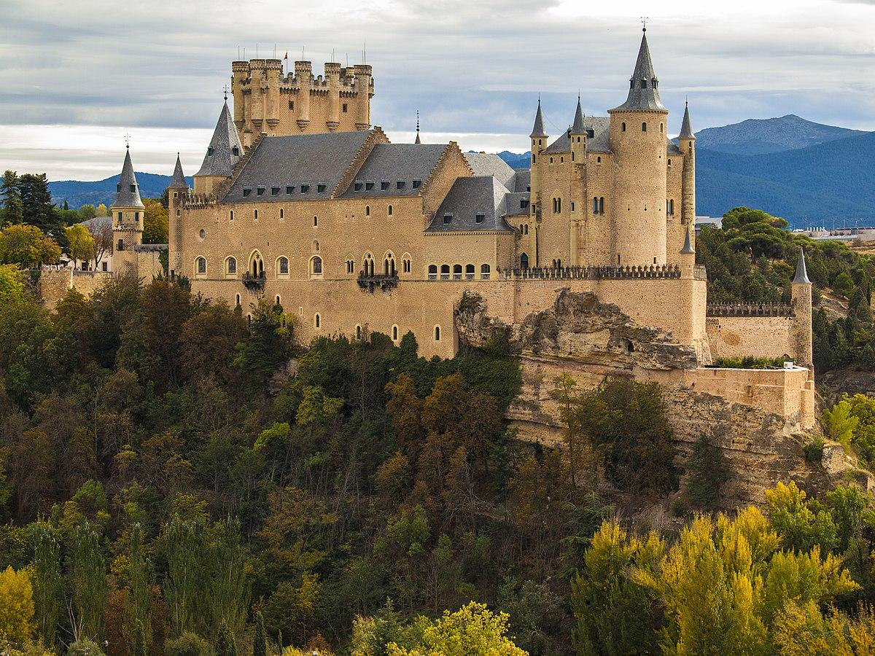
Maths
Numbers to 10
National Curriculum Objective:
Pupils should be taught identify one more and one less than a given number. The should identify and represent numbers using objects and pictorial representations including the number line, and use the language of: equal to, more than, less than (fewer), most, least. Pupils should read and write numbers from 1 to 20 in numerals and words.

Number Bonds

Addition and Subtraction
National Curriculum Objective:
Pupils should read, write and interpret mathematical statements involving addition (+), subtraction (–) and equals (=) signs. They should represent and use number bonds and related subtraction facts within 20. Pupils will add and subtract one-digit and two-digit numbers to 20, including zero and solve one-step problems that involve addition and subtraction, using concrete objects and pictorial representations, and missing number problems such as 7 = – 9.

English
Fiction- The Worst Princess
Non- Fiction: King Leonard’s Teddy
Skills Covered:
Write a sequence of sentences to form short narratives, including personal experiences and those of others (real or fictional)
Use the joining word and
Use capital letters and full stops to demarcate some sentences accurately
Use capital letters for proper nouns
Use exclamation marks to demarcate some sentences
Use their Phase 2, Phase 3, Phase 4 and Phase 5 phonic knowledge to write words in ways which match their spoken sounds – many being spelt correctly and others being phonetically plausible
Spell most Year 1 common exception words taught
Form many lower case and capital letters accurately
Write with many letters accurate in shape and size, including capital letters and digits
Use spacing between words
Re-read writing to check that it makes sense
Read aloud their writing to each other and the teacher

Castles

Art
Sketching
Children to use drawing to develop and share their ideas, experiences and imagination. They will develop a wide range of art and design techniques in using colour, pattern, texture, line, shape, form and space.

Skills covered:
Use a variety of tools, inc. pencils, rubbers, crayons, pastels, felt tips, charcoal, ballpoints, chalk and other dry media.
Begin to explore the use of line, shape and colour
Use a wide variety of media, inc. photocopied material, fabric, plastic, tissue, magazines, crepe paper, etc.
Work on their own, and collaboratively with others, on projects in 2 and 3 dimensions and on different scales.
Review what they and others have done and say what they think and feel about it. E.g. Annotate sketchbook
Make rubbings.
Build a repeating pattern and recognise pattern in the environment.
Use a sketchbook to gather and collect artwork.

RE
I can say how it felt to make something.
I can remember the Christian Creation story and talk about it.
I can express an opinion about the Christian belief about creation.

ICT
To understand what algorithms are; how they are implemented as programs on digital devices; and that programs execute by following precise and unambiguous instructions. Create and debug simple programs. Use logical reasoning to predict the behaviour of simple programs. Recognise common uses of information technology beyond school.
Skills covered:
To Sequence a series of pre-written instructions to create an algorithm.
Break an activity down into simple steps
Independently list the steps in their own algorithms, test them and correct any mistakes
Combine more than one command into a device to make a simple program

Music
Pupils should be taught to use their voices expressively and creatively by singing songs and speaking chants and rhymes.

They will play tuned and untuned instruments musically. Pupils will listen with concentration and understanding to a range of high-quality live and recorded music.

Singing
Sing simple songs, chants and rhymes (e.g. Boom Chicka Boom) from memory,
singing collectively and at the same pitch, responding to simple visual directions (e.g.
stop, start, loud, quiet) and counting in.

Listening
Developing pupils’ shared knowledge and understanding of the stories, origins, traditions, history and social context of the music they are listening to, singing and playing.

[History Lessons: Understanding of National Anthem]
Composing
Improvise simple vocal chants, using question and answer phrases.
Create musical sound effects and short sequences of sounds in response to
stimuli, e.g. a rainstorm or a train journey. Combine to make a story, choosing and
playing classroom instruments (e.g. rainmaker) or sound-makers (e.g. rustling
leaves).

Musicianship
Pulse/Beat
Walk, move or clap a steady beat with others, changing the speed of the beat as the
tempo of the music changes.

Rhythm
Perform short copycat rhythm patterns accurately, led by the teacher.

Pitch
Listen to sounds in the local school environment, comparing high and low sounds.
Sing familiar songs in both low and high voices and talk about the difference in sound.

[Geography Lesson: Outdoor learning/Listening to sounds in local environment/ Investigating surrounding/ Human and physical features]

P.E
Games- Attack, Defend, Shoot
National Curriculum Objective:
Pupils should develop fundamental movement skills, become increasingly competent and
confident and access a broad range of opportunities to extend their agility, balance and
coordination, individually and with others. They should be able to engage in competitive
(both against self and against others) and co-operative physical activities, in a range of
increasingly challenging situations.

Pupils should be taught to:

Master basic movements including running, jumping, throwing and catching, as well as
developing balance, agility and coordination, and begin to apply these in a range of
activities

Participate in team games, developing simple tactics for attacking and defending

Skills Covered:
Recognise rules and apply them in competitive games

Make decisions about how to defend a target.

Aim at targets and shoot from varying distances, defended and unopposed

Roll, slide or throw a beanbag or ball with accuracy

Use change of direction and speed in open play

Come up with creative ways of manipulating difference objects such as balls and beanbags

Work in collaboration with others to attack and score points

Show motivation to improve and attempt more difficult challenges

History
Queen VIctoria’s Reign

National Curriculum Objective:
Pupils to look at the lives of significant individuals in the past who have contributed to national and international achievements. Children to look at significant historical events, people and places in their own locality.
Skills covered:
Sequence 3 or 4 artefacts from distinctly different periods of time
Match objects to people of different ages

They know and recount episodes from stories about the past

Use stories to encourage children to distinguish between fact and fiction.

Find answers to simple questions about the past from sources of information e.g. artefacts

Communicate their knowledge through:

Discussion….
Drawing pictures…
Drama/role play..
Making models…..
Writing..
Using ICT

Science
Naming and Identifying Materials and Seasonal Changes
National Curriculum Objective:

Pupils should be taught to distinguish between an object and the material from which it is made. They will identify and name a variety of everyday materials, including wood, plastic, glass, metal, water and rock.
Pupils should be taught to observe changes across the four seasons and describe weather associated with the seasons and how day length varies.

Skills covered:
Materials
Distinguish between an object and the material from which it is made
Identify and name a variety of everyday materials, including wood, plastic, glass, metal, water, and rock.
Seasonal Changes
Observe changes across the four seasons.
Observe and describe weather associated with the seasons

PSHCE

My Happy Minds
See themselves as a valuable individual
Build constructive and respectful relationships.
Name and describe people who are familiar to them.
Understand some places are special to members of their community.
Recognise that people have different beliefs and celebrate special times in different ways.

Skills Covered:
All about me activities.
Me and my family.
Introduce riles and Coop ways of being.
Introduction to My Happy Mind.
Introduction to Feelings Flowers
Make special people models.
Self portraits.

Story Project
The Jar of Happiness by Ailsa Burrows
I can tell you what makes me happy.
I can tell you some ways that I make others feel happy.
I can tell you what makes me feel sad.
I can tell you some simple strategies that help me when I feel sad.
I can explain how friends and family can make us feel happy.

Skills Covered:
The characteristics of friendships, including mutual respect, truthfulness, trustworthiness, loyalty, kindness, trust, sharing interests and experiences and support with problems and difficulties.
Simple self-care techniques, including the importance of rest, time spent with friends and family and the benefits of hobbies and interests.
That there is a normal range of emotions (e.g. happiness, sadness, anger, fear, surprise,
nervousness) and scale of emotions that all humans experience in relation to different experiences and situations.
Different things they can do to manage big feelings, to help calm themselves down and/or change their mood when they don't feel good.

