Year 4 Autumn 2
English
English texts: A christmas in time.
Year 4 writing assessment objectives:
Narrative
Poetry
Write for both fictional and non-fictional purposes
Use expanded noun phrases to describe and add detail to settings and characters
Use co-ordinating and subordinating conjunctions
Use prepositions to express place and time
Demarcate sentences with capital letters and full stops,
Spell common exception words(Year 1-2), spellings with contracted forms and Y1/2
Spelling rules correctly
spell some words correctly (Year 3-4)
Write capital letters and digits of the correct size, orientation and relationship to one another and to lower-case letters
Use paragraphs or sections to organise and structure according to purpose and audience

Our Magical City
Geography
National Curriculum objectives
Human geography, including: types of settlement and land use, economic activity including trade links, and the distribution of natural resources including energy, food, minerals and water

Use fieldwork to observe, measure, record and present the human and physical features in the local area using a range of methods, including sketch maps, plans and graphs, and digital technologies.

Progression in skills objectives
Ask and respond to questions and offer their own ideas.
Collect and record evidence with some aid
Make a map of a short route experienced, with features in correct order;
Draw a sketch map from a high viewpoint.
Begin to identify significant places and environments
Use large and medium scale OS maps.
Make a simple scale drawing.
Use 4 compass points well:
Begin to use 8 compass points;
Use letter/no. co-ordinates to locate features on a map confidently.
Follow a route on a large scale map.
Know why a key is needed.
Begin to recognise symbols on an OS map.

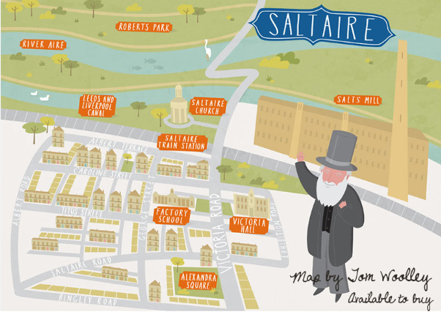

Science

National Curriculum objectives
compare and group materials together, according to whether they are solids, liquids or gases

observe that some materials change state when they are heated or cooled, and measure or research the temperature at which this happens in degrees Celsius (°C)

identify the part played by evaporation and condensation in the water cycle and associate the rate of evaporation with temperature

Progression in skills objectives

Compare and group materials together, according to whether they are solids, liquids or gases

Observe that some materials change state when they are heated or cooled, and measure or research the temperature at which this happens in degrees Celsius (°C)

Identify differences, similarities or changes related to simple scientific ideas and processes

Use straightforward scientific evidence to answer questions or to support his/her findings

Identify the part played by evaporation and condensation in the water cycle and associate the rate of evaporation with temperature
Maths

National Curriculum objectives
To identify types of angles.
To compare angles.
To classify triangles.
To classify quadrilaterals.
To identify symmetrical figures.
To draw lines of symmetry.
To draw symmetrical figures.
To make symmetrical figures.
To classify shapes based on angles, lines of symmetry and number of sides.
To count in sixes, sevens and nines.
To multiply by 9, 7, 11 and 12.
To divide by 6, 7 and 9.
To multiply and divide by 11 and 12.
To divide with remainders.
To solve word problems involving multiplication and division
To solve multi-step problems (in the context of measures).
To solve problems involving multiplication and division (all possibilities).
To solve problems involving multiplication and division (multi-step).
To solve problems involving multiplication and division (scaling/comparison)

Progression in skills objectives

Geometry - To identify, compare and classify angles in triangles and quadrilaterals.
To find symmetry in shapes.
Multiplication and division - To be able to multiply and divide by 7, 9, 11 and 12.
To solve word problems.

Design Technology

National Curriculum objectives
Use research and develop design criteria to inform the design of innovative, functional, appealing products that are fit for purpose, aimed at particular individuals or groups.
Generate, develop, model and communicate their ideas through discussion, annotated sketches, cross-sectional and exploded diagrams, prototypes, pattern pieces and computer-aided design.
Select from and use a wider range of materials and components, including construction materials, textiles and ingredients, according to their functional properties and aesthetic.

To select from and use a wider range of tools and equipment to perform practical tasks [for example, cutting, shaping, joining and finishing], accurately.
To prepare and cook a variety of predominantly savoury dishes using a range of cooking techniques.
To understand seasonality, and know where and how a variety of ingredients are grown, reared, caught and processed.
Progression in skills objectives
Generate ideas, considering the purposes for which they are designing
Make labelled drawings from different views showing specific features
Develop a clear idea of what has to be done, planning how to use materials, equipment and processes, and suggesting alternative methods of making, if the first attempts fail
Use simple graphical communication techniques

Sew using a range of different stitches, weave and knit

Join and combine materials and components accurately in temporary and permanent ways

Spanish

National Curriculum objectives
Listen attentively to spoken language and show understanding by joining in and responding

Develop accurate pronunciation and intonation so that others understand when they are reading aloud or using familiar words and phrases

Describe people, places, things and actions orally

Understand basic grammar appropriate to the language being studied, including feminine and masculine forms

Progression in skills objectives
Listen to and follow a short story

Listen for specific words and phrases

Listen to and join a singing a Spanish song

Pronounce some words accurately

Ask and answer questions

Follow a short text as it is read aloud and demonstrate understanding of the text through drawing

Follow a story using visual clues

Scan a text to identify key words

Recognise some letters of the alphabet

Computing
National Curriculum objectives
Design, write and debug programs that accomplish specific goals, including controlling or simulating physical systems; solve problems by decomposing them into smaller parts.

Progression in skills objectives
Understand the composition of a range of programs by decomposing them into their key components.

Debug one instance of pre-written code with deliberate mistakes.

PE National Curriculum objectives

Gymnastics
Pupils should continue to apply and develop a broader range of skills, learning how to use them in different ways and to link them to make actions and sequences of movement. They should enjoy communicating, collaborating and competing with each other. They should develop an understanding of how to improve in different physical activities and sports and learn how to evaluate and recognise their own success.
Develop flexibility, strength, technique, control and balance [for example, through athletics and gymnastics].
Compare their performances with previous ones and demonstrate improvement to achieve their personal best.
Progression in skills objectives
Gymnastics
Links skills with control, technique, coordination and fluency.
Understands composition by performing more complex sequences.
Beginning to use gym vocabulary to describe how to improve and refine performances.
Develops strength, technique and flexibility throughout performances.
Creates sequences using various body shapes and equipment.
Combines equipment with movement to create sequences.
Physically Active Lessons
Watches and describes performances accurately.
Beginning to think about how they can improve their own work.
Work with a partner or small group to improve their skills.
Make suggestions on how to improve their work, commenting on the similarities and differences.
Can describe the effects exercise has on the body.
Can explain the importance of exercise and a healthy lifestyle.
Understands the need to warm up and cool down
.

RE
Christianity - Progression in Skills
Design a symbolic object to show the significance of Christmas or the Christmas holiday.
Describe one thing a Christian might learn about Jesus from a Christmas symbol.
Ask questions about what Christmas means to Christians and compare this with what it means to me.

PSHE
National Curriculum objectives
They will learn that this is Neuroplasticity, and they can do anything they put their mind to.
How they use each part of Team H-A- P and reflect on when they use them to develop their understanding.
How the Amygdala reacts to real and perceived danger.
About the brain's structure and how neurons carry messages to create neural pathways.
More about how to look after their brains and what happens if we don't.
Penguin Pig by Stuart Spendlow
I can tell you the risks of making friends online including the risks of talking to people I have never met and how people sometimes pretend to be someone they are not.
I can tell you why it is important to treat people online the same as you treat people in person.

