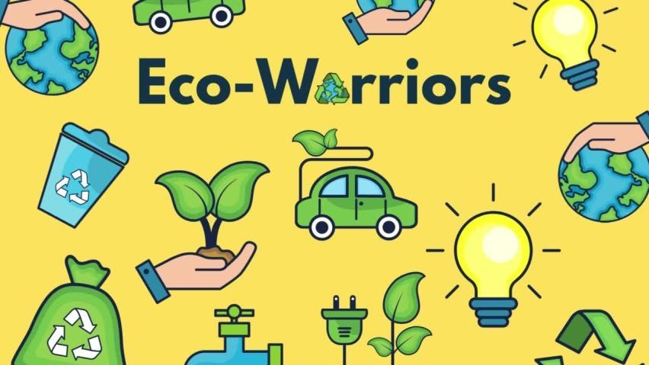
Maths
Calculation: Addition and Subtraction Word Problems
National Curriculum Objective:
Pupils should be taught to: read, write and interpret mathematical statements involving addition (+), subtraction (–) and equals (=) signs represent and use number bonds and related subtraction facts within 20. They should add and subtract one-digit and two-digit numbers to 20, including zero. Pupils will solve one-step problems that involve addition and subtraction, using concrete objects and pictorial representations, and missing number problems such as 7 = – 9.
Fractions
National Curriculum Objective:
Pupils to recognise, find and name a half as one of two equal parts of an object, shape or quantity. They will recognise, find and name a quarter as one of four equal parts of an object, shape or quantity.
Time
National Curriculum Objective:
Pupils to measure and begin to record time (hours, minutes, seconds).

English
Fiction- Diary Entry
Dear Earth by Isabell Otter
Non- Fiction- Newspaper Article
Greta Thunberg- Eco Heroes- Little People, Big Dreams
Poetry: Poems about animals
Skills Covered:
write a sequence of sentences to form short narratives, including personal experiences and those of others (real or fictional)
use the joining word and
use simple past and present verbs mostly accurately
use capital letters and full stops to demarcate some sentences accurately
use capital letters for proper nouns use question marks to demarcate some sentences
use exclamation marks to demarcate some sentences
use their Phase 2, Phase 3, Phase 4 and Phase 5 phonic knowledge to write words in ways which match their spoken sounds – many being spelt correctly and others being phonetically plausible
add the suffixes –ing, -ed
Spell most Year 1 common exception words taught
form many lower case and capital letters accurately
write with many letters accurate in shape and size, including capital letters and digits use spacing between words
re-read writing to check that it makes sense
read aloud their writing to each other and the teacher

Eco- Warriors
Science
Animals including Humans and Seasonal Changes
National Curriculum Objective:
Children will identify and name a variety of common animals including fish, amphibians, reptiles, birds and mammals They will identify and name a variety of common animals that are carnivores, herbivores and omnivores Children to describe and compare the structure of a variety of common animals (fish, amphibians, reptiles, birds and mammals including pets). They will identify, name, draw and label the basic parts of the human body and say which part of the body is associated with each sense
Pupils should be taught to ide observe changes across the four seasons and describe weather associated with the seasons and how day length varies.
Skills covered:
Animals including Human
Identify and name a variety of common animals including fish, amphibians, reptiles, birds and mammals

Identify and name a variety of common animals that are carnivores, herbivores and omnivores

Describe and compare the structure of a variety of common animals (fish, amphibians, reptiles, birds and mammals, including pets)

Identify, name, draw and label the basic parts of the human body and say which part of the body is associated with each sense.

Describe the basic needs of animals, including humans, for survival (water, food and air).

Describe the importance for humans of exercise, eating the right amounts of different types of food, and hygiene.

Seasonal Changes
Observe changes across the four seasons.
Observe and describe weather associated with the seasons and how day length varies

History
The Invention of Plastic

National Curriculum Objective:
Pupils should be taught about changes within living memory. Where appropriate, these should be used to reveal aspects of change in national life.
Skills covered:
Recognise the difference between past and present in their own and others lives
Use stories to encourage children to distinguish between fact and fiction
Find answers to simple questions about the past from sources of information e.g. artefacts, (see 4a)
Communicate their knowledge through:
Discussion….
Drawing pictures…
Drama/role play.. Writing

PE
Dance
National Curriculum Objective:
Pupils should develop fundamental movement skills, become increasingly competent and confident and access a broad range of opportunities to extend their agility, balance and coordination, individually and with others. They should be able to engage in competitive (both against self and against others) and co-operative physical activities, in a range of increasingly challenging situations.

Pupils should be taught to:

Master basic movements including running, jumping, throwing and catching, as well as developing balance, agility and coordination, and begin to apply these in a range of activities

Perform dances using simple movement patterns.

Demonstrate understanding that a dance has a start, middle and end

Confident to explore space within their dances and movements

Simplistically use concepts such as unison and mirroring in dance, copying examples

Perform basic body actions along with music

Remember and repeat simple movement patterns

Move with control and show spatial awareness

Show strength and flexibility during different types of activity such as movement phrases or starter activities

Work with a partner to use repeating motifs in a dance movement phrase

Tap into emotions to respond to the feelings in the music translating to body movement

RE
Jesus as a Friend

Talk about my friends and why I like them.

Remember a story about Jesus showing friendship and talk about it.

Say how Jesus tried to be a good friend.
can talk about a person I admire.

ICT
Media
Use technology purposefully to create, organise, store, manipulate, and retrieve digital content.
Skills covered:
Use the shape tool and the line tools
Make careful choices when painting a digital picture
Explain why a tool was used
Use a computer independently to paint a picture
Compare painting a picture on a computer and on paper.

Art
Seascape and Van Gogh
Pupils to learn about the work of a range of artists, craft makers and designers, describing the differences and similarities between different practices and disciplines, and making links to their own work.

Pupils to use drawing, painting and sculpture to develop and share their ideas, experiences and imagination

Skills Covered:

Work on a range of scales e.g. large brush on large paper etc.
To use different sizes of paint brushes and different paint brush strokes
Ask and answer questions about the starting points for their work and the processes they have used.
Develop their ideas.

Explore the differences and similarities within the work of artists, craftspeople and designers in different times and cultures.

Create images from imagination, experience or observation.

Mix and match colours to artefacts and objects.

Mix a range of secondary colours, shades and tones.

Music

Pupils should be taught to use their voices expressively and creatively by singing songs and speaking chants and rhymes.They will play tuned and untuned instruments musically. Pupils will listen with concentration and understanding to a range of high-quality live and recorded music. They will experiment with, create, select and combine sounds using the inter-related dimensions of music.

Skills covered:
Singing (Craig)
Sing simple songs with a very small range, mi-so (e.g. Hello, how are You), and then slightly wider (e.g. Bounce High, Bounce Low).

Listening
Listening to recorded and live performances.

[Geography Lesson: Song on oceans around the world/ Record performance]

Composing
Explore percussion sounds to enhance storytelling, e.g.
ascending xylophone notes to suggest Jack climbing the beanstalk,
quiet sounds created on a rain stick/ shaker to depict a shower,
regular strong beats played on a drum to replicate menacing footsteps.

[English Lesson: Somebody Swallowed Stanley/ Under the sea sounds using instruments]

Musicianship
Pulse/beat
Use body percussion, (e.g. clapping, tapping, walking) to a steady beat.

Rhythm
Perform short repeating rhythm patterns (ostinato) while keeping in time with a steady beat.

Pitch
Sing familiar songs in both low and high voices and talk about the different sounds.

PSHCE

Celebrate
What character strengths are and how they make us unique and special.
About the 5 Character strengths and what they mean.
How the best way to learn more about your strengths is to notice them.
That our strengths are like superpowers, and when we use them, it helps us to be our best and feel happy.
That it is nice to tell other people when they use their strengths, as it makes them feel good.

Skills Covered:
H21: to recognise what makes them special
H22: to recognise the ways in which we are all unique
H23: to identify what they are good at, what they like and dislike

Story Project
Look Up by Nathan Byron
I can tell you what makes me an individual.
I can tell you what my strengths are.
I can teach someone else about something I am good at.
I can tell you some of the effects of spending too much time online.
I can tell you how to keep safe on the roads.

Skills Covered:
RKR8. The importance of self-respect and how this links to their own happiness. Pupils should have opportunities to think about how they foster their own self-esteem and build a strong sense of their own identity, including through developing skills and interests.
WO3. The benefits of limiting time spent online, the risks of excessive time spent on electronic devices and the impact of positive and negative content online on their own and others’ mental and physical wellbeing.
PS2. How to recognise risk and keep safe around roads, railways, including level crossings, and water, including the water safety code.

