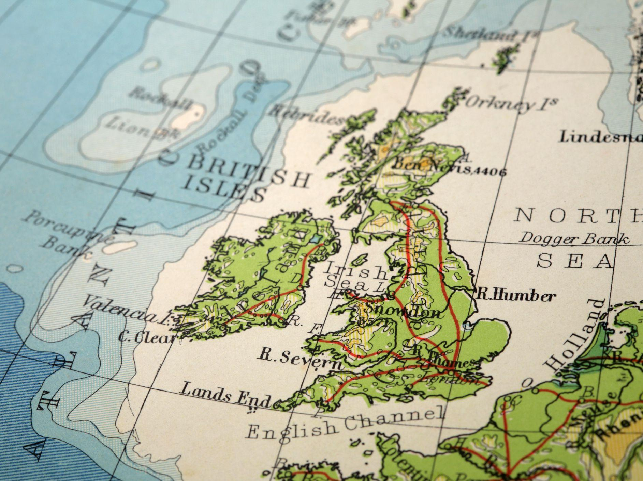
Beautiful Britain
Maths

Chapter 4: Word problems:
Solve problems involving multiplication and division

Chapter 6: Fractions
Recognise mixed numbers and improper fractions and convert one form to the other.
Identify, name, and write equivalent fractions of a given fractions, represented visually, including tenths and hundredths.
Compare and order fractions whos denominators are all multiples of the same number.
Add and subtract fractions with the same denominator and denominators that are multiples of the same number.
Multiply proper fractions and mixed numbers by whole numbers, supported by materials and diagrams.

Texts
English:
Henry VIII’s Secret Diaries – Diary Entry
The Really Useful Guide to Kings and Queens of England – Non-chronological report

Guided Reading:
Little Elizabeth

Class Reader:
Holes by Louis Sacher
Science
Topic: Forces
N/C and Progression in skills:
Explain that unsupported objects fall towards the Earth because of the force of gravity acting between the Earth and the falling object.
Identify the effects of air resistance, water resistance and friction, that act between moving surfaces
Recognise that some mechanisms including levels, pulleys and gears allow a smaller force to have a greater effect.

SPaG

Grammar:
Write effectively for a range of purposes and audiences, selecting language that shows good awareness of the reader (e.g. the use of the first person in a diary)
In non-narrative writing, use simple devices to structure the writing and support the reader (e.g. headings, subheadings and bullet points)
Use relative clauses, sometimes omitting the relative pronoun Use some punctuation for parenthesis (brackets, commas and dashes)
Use a wide range of clause structures, sometimes varying their position within a sentence
Showing a growing awareness of making writing succinct by using all grammar and punctuation taught so far precisely to engage the reader (e.g. the use of first person in a diary)
Spelling:
Homophones and other words that are often confused
Words containing the letter -string ough

History

Topic: British Monarchs throughout History
A study of an aspect or theme in British history that extends pupils’ chronological knowledge beyond 1066 (Changing Power of Monarchs).

N/C pupils should continue to: Develop a chronologically secure knowledge and understanding of British, local and world history, establishing clear narratives within and across the periods they study. They should note connections, contrasts and trends over time and develop the appropriate use of historical terms. They should regularly address and sometimes devise historically valid questions about change, cause, similarity and difference, and significance

Progression in skills:
Use evidence to build up a picture of a past event.
Select relevant sections of information.
Use the library and internet for research with increasing confidence Know and sequence key events of time studied.
Use relevant and period labels.
Make comparisons between different times in the past.
Study aspects of different people – differences between men and women.
Compare life in early and late ‘times’ studied.
Compare an aspect of life with the same aspect in another period.
Recall, select and organise historical information.
Communicate their knowledge and understanding.
Compare accounts of events from different sources – fact or fiction.
Offer some reasons for different versions of events.
Begin to identify primary and secondary sources
Computing
Topic: Media
N/C Pupils should be taught to: Select, use and combine a variety of software (including internet services) on a range of digital devices to design and create a range of programs, systems and content. Use technology safely, respectfully and responsibly; recognise acceptable/unacceptable behaviour; identify a range of ways to report concerns about content and contact
Progression in skills:
Create a short animation film or presentation.
Plan, create and deliver a multimedia presentation to an audience that it has been written for.
Religious Education
Topic: Sikhism – Belief and Moral Values
I can statements:
I can explain how some stories can teach people about what is important and how to behave
I can recognise that stories can be an important way of expressing belief and meaning and can explain the relevance of a Sikh story
I can explain how some stories can teach Sikhs about what is important in life and relate this to non-Sikhs

Art
Artist Study: Stephen Wiltshire
N/C pupils should be taught to: develop their techniques, including their control and their use of materials, with creativity, experimentation and an increasing awareness of different kinds of art, craft and design, create sketch books to record their observations and use them to review and revisit ideas, improve their mastery of art and design techniques, including drawing, painting and sculpture with a range of materials [for example, pencil, charcoal, paint, clay], about great artists, architects and designers in history.
Progression in skills: .
Question and make thoughtful observations about starting points and select ideas and processes to use in their work.
Explore the potential properties of the visual elements, line, tone, pattern, texture, colour, and shape.
Create imaginative work from a variety of sources.
Demonstrate a secure knowledge about warm and cold and complementary and contrasting colours.
Work on preliminary studies to test media and materials. Use a variety of source material for their work.
Adapt their work according to their views and describe how they might develop it further. Use ICT.
Investigate art, craft and design in the locality and in a variety of genres, styles and traditions.
Work on preliminary studies to test media and materials.
Physical Education
Topic: Dance
N/C Pupils should be taught to: apply and develop a broader range of skills, learning how to use them in different ways and to link them to make actions and sequences of movement, enjoy communicating, collaborating and competing with each other, develop an understanding of how to improve in different physical activities and sports and learn how to evaluate and recognise their own success, develop flexibility, strength, technique, control and balance [for example, through athletics and gymnastics]. Perform dances using a range of movement patterns and compare their performances with previous ones and demonstrate improvement to achieve their personal best.

Progression in skills:
Beginning to exaggerate dance movements and motifs (using expression when moving).
Demonstrates strong movements throughout a dance sequence.
Combines flexibility, techniques and movements to create a fluent sequence.
Moves appropriately and with the required style in relation to the stimulus. e.g using various levels, ways of travelling and motifs.
Beginning to show a change of pace and timing in their movements.
Uses the space provided to his maximum potential. Improvises with confidence, still demonstrating fluency across their sequence.
Modifies parts of a sequence as a result of self and peer evaluation.
Uses more complex dance vocabulary to compare and improve work.
Topic: Swimming
N/C Pupils should be taught to: swim competently, confidently, and proficiently over a distance of at least 25 metres, use a range of strokes effectively [for example, front crawl, backstroke, and breaststroke]. Perform safe self-rescue in different water-based situation and compare their performances with previous ones and demonstrate improvement to achieve their personal best.

Progression in skills:
Swims competently, confidently and proficiently over a distance of at least 25 metres.
Uses a range of strokes effectively e.g. front crawl, backstroke and breaststroke.
Performs safe self-rescue in different water-based situations
Spanish
National curriculum:
listen attentively to spoken language and show understanding by joining in and responding
explore the patterns and sounds of language through songs and rhymes and link the spelling, sound and meaning of words
engage in conversations; ask and answer questions; express opinions and respond to those of others; seek clarification and help
speak in sentences, using familiar vocabulary, phrases and basic language structures
develop accurate pronunciation and intonation so that others understand when they are reading aloud or using familiar words and phrases
present ideas and information orally to a range of audiences
read carefully and show understanding of words, phrases and simple writing
appreciate stories, songs, poems and rhymes in the language
broaden their vocabulary and develop their ability to understand new words that are introduced into familiar written material, including through using a dictionary
write phrases from memory, and adapt these to create new sentences, to express ideas clearly
describe people, places, things and actions orally and in writing
understand basic grammar appropriate to the language being studied, including (where relevant): feminine, masculine and neuter forms and the conjugation of high-frequency verbs; key features and patterns of the language; how to apply these, for instance, to build sentences; and how these differ from or are similar to English.

Progression in Skills
Can remember and say fruit and vegetables nouns
Can participate in a simple dialogue at the market
Can follow and say simple instructions to make a simple fruit/veg recipe
Music
N/C Pupils should be taught to: play and perform in solo and ensemble contexts, using their voices and playing musical instruments with increasing accuracy, fluency, control and expression, use and understand staff and other musical notations, appreciate and understand a wide range of high-quality live and recorded music drawn from different traditions and from great composers and musicians and develop an understanding of the history of music.
Progression in skills:
Identify and control different ways percussion instruments make sounds.
Play accompaniments with control and accuracy.
Create different effects using combinations of pitched sounds. Identify different starting points or composing music.
Explore, select combine and exploit a range of different sounds to compose a soundscape.
Write lyrics to a known song. Compose a short song to own lyrics based on everyday phrases.
Compose music individually or in pairs using a range of stimuli and developing their musical ideas into a completed composition.
Sing with expression and rehearse with others.
Sing a round in two parts and identify the melodic phrases and how they fit together.
Sing confidently in class, in small groups and alone, and begin to begin to have an awareness of improvisation with the voice.
PSHE
Topic: Celebrate
Lesson objectives:
How the 24 character strengths are organised into 6 key virtues: Wisdom, Courage, Humanity, Justice, Temperance, and Transcendence.
That strength spotting shows children how strengths can be used in different ways.
That they still have all 24 strengths, but when they use their Top 5 Team H-A- P feels at its best.
How they can move their strengths around and grow strengths by practising them through Neuroplasticity.
That when they stop and reflect on using their strengths, their Hippocampus will store it as a memory.
They will learn that when faced with a similar situation, they can remember how that strength can help.
How strength spotting can help Team H-A- P feel happy as when we use our strengths, Dopamine gets released, and we feel confident.
They will also learn that using our strengths can help them manage their Cortisol levels
Story Project: Mum and Dad Glue by Kes Grey
Lesson objectives:
I can tell you some of the reasons why married or unmarried couples may choose to separate.
I am aware of some of the feelings associated with separation.
I can tell you what an affirmation is and can write one for myself.
I can explain how I could help a friend who is experiencing a difficult situation.
Progression in Skills:
Where and how to seek support (including recognising the triggers for seeking support), including whom in school they should speak to if they are worried about their own or someone else’s mental wellbeing or ability to control their emotions (including issues arising online).

