Events this term:  First day of Winter 21st December  Chinese New Year 17th February  Shrove Tuesday 17th February  Holi 4th March  Mother’s Day 15th March  First day of Spring 20th March  Easter 5th April | Literacy  -Understand the 5 key concepts about print (Print has meaning, parts of a book, directionality, page sequencing, print purpose)  -Use letter knowledge in early writing  -Write some letters accurately  -Blend sounds in words  -Extend conversations about stories using new vocabulary  -Read letter groups that represent one sound (diagraphs and trigraphs) |  | The world/Expressive art and design  -Plant seeds and care for plants  -Understand life cycles  -Explore the natural world  -Build using imagination  - Explore colour mixing  -Explore music making and dance
Personal, social and emotional  My Happy Minds - Celebrate and Appreciate  Story project - Oliver’s vegetables  and Here we are  -Understand rules and why they are important  -Resolve their conflicts  -Identify and moderate feelings  -Selecting activities and resources | 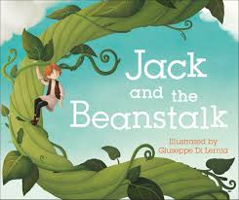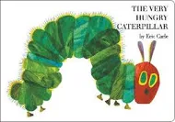  Amazing nature |  | Communication and language  -Understand why questions  -Build a repertoire of songs  -Develop communication  -Use longer sentences  -Start a conversation and continue it  -Use new vocabulary  -Ask questions  -Listen to and talk about stories
Mathematical development  Counting  Counting and ordering  Addition  Comparing and ordering  Patterns  Measuring length and height  Capacity  2d and 3d shapes | Physical development  -Confidently and safely use a range of small and large apparatus  -Revise movement skills: rolling, walking, running, skipping, crawling, jumping, hopping, climbing  -Develop small motor skills to use a range of tools competently  -Hold a pencil with a pincer grip with good control  -To be able to talk about health and well being  -To be able to dress and undress with increasing independence |  | Things to remember  Book bags - Monday  PE day - Monday

