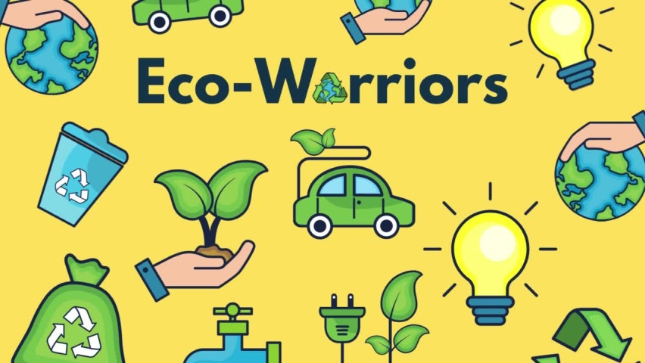

English

**Fiction- Diary Entry**

Dear Earth by Isabell Otter

**Non- Fiction- Information Text**

Somebody Swallowed Stanley by Sarah Roberts

**Poetry: Poems about plants**

I am the Seed That Grew the Tree by Fiona Waters

Skills Covered:

write a sequence of sentences to form short narratives, including personal experiences and those of others (real or fictional)

use the joining word and

use simple past and present verbs mostly accurately

use capital letters and full stops to demarcate some sentences accurately

use capital letters for proper nouns use question marks to demarcate some sentences

use exclamation marks to demarcate some sentences

use their Phase 2, Phase 3, Phase 4 and Phase 5 phonic knowledge to write words in ways which match their spoken sounds – many being spelt correctly and others being phonetically plausible

add the suffixes –ing, -ed

Spell most Year 1 common exception words taught

form many lower case and capital letters accurately

write with many letters accurate in shape and size, including capital letters and digits use spacing between words

re-read writing to check that it makes sense

read aloud their writing to each other and the teacher

Maths

**Shapes and Patterns**

National Curriculum Objective:

Pupils will recognise and name common 2-D and 3-D shapes.

**Comparing Heights and Length**

National Curriculum Objective:

Pupils to compare, describe, solve practical problems and record lengths, heights, mass, weight, capacity, volume and time. They should recognise and know the value of different denominations of coins and notes. Children will sequence events in chronological order using language. They will recognise and use language relating to dates, including days of the week, weeks, months and years. Children to tell the time to the hour and half past the hour and draw the hands on a clock face to show these times

**Counting to 100**

National Curriculum Objective:

Pupils will count to and across 100, forwards and backwards, beginning with 0 or 1, or from any given number. They will count, read and write numbers to 100 in numerals; count in multiples of twos, fives and tens. Children will be given a number and will identify one more and one less than. Pupils will identify and represent numbers using objects and pictorial representations including the number line, and use the language of: equal to, more than, less than (fewer), most, least.

**Eco- Warriors**



Geography

**What does the Earth look like from space?**

Pupils will name and locate the world’s seven continents and five oceans. The will use world maps, atlases and globes to identify the United Kingdom and its countries, as well as the countries, continents and oceans studied at this key stage. Children will use basic geographical vocabulary to refer to: key physical features, including: beach, cliff, coast, forest, hill, mountain, sea, ocean, river, soil, valley, vegetation, season and weather. Key human features, including: city, town, village, factory, farm, house, office, port, harbour and shop.

Skills covered:

Geographical Enquiry

Teacher led enquiries, to ask and respond to simple closed questions.

Use information books/pictures as sources of information

Using Maps

Recognise that it is about a place.

.

Scale/Distance

Use relative vocabulary (e.g. bigger/smaller, like/dislike)

Style of Map

Picture maps and globes

Science

**Animals including Humans**

National Curriculum Objective:

Children will identify and name a variety of common animals including fish, amphibians, reptiles, birds and mammals They will identify and name a variety of common animals that are carnivores, herbivores and omnivores Children to describe and compare the structure of a variety of common animals (fish, amphibians, reptiles, birds and mammals including pets). They will identify, name, draw and label the basic parts of the human body and say which part of the body is associated with each sense

Skills covered:

**Working Scientifically**

Ask simple questions and recognise that they can be answered in different ways.

Observe closely, using simple equipment.

Perform simple tests.

Identify and classify.

Use their observations and ideas to suggest answers to questions

Gather and record data to help answer questions.

**Animals including Human**

Identify and name a variety of common animals including fish, amphibians, reptiles, birds and mammals

Identify and name a variety of common animals that are carnivores, herbivores and omnivores

Describe and compare the structure of a variety of common animals (fish, amphibians, reptiles, birds and mammals, including pets)

Identify, name, draw and label the basic parts of the human body and say which part of the body is associated with each sense.



Art

**Clay whales, Sea collage, Plasticine sea creatures and Wax crayons whales**

Children will use a range of materials creatively to design and make products. They will use drawing, painting and sculpture to develop and share their ideas, experiences and imagination.

Skills covered:

Ask and answer questions about the starting points for their work and the processes they have used. Develop their ideas.

Experiment with, construct and join recycled, natural and man-made materials more confidently.

How to thread a needle, cut, glue and trim material.

Create images from imagination, experience or observation.

Explore sculpture with a range of malleable media, especially clay.

PE

**Dance**

National Curriculum Objective:

Pupils should develop fundamental movement skills, become increasingly competent and confident and access a broad range of opportunities to extend their agility, balance and coordination, individually and with others. They should be able to engage in competitive (both against self and against others) and co-operative physical activities, in a range of increasingly challenging situations.They should perform dances using simple movement patterns.

Skills Covered:

Dance

Copies and explores basic movements and body patterns.

Remembers simple movements and dance steps.

Links movements to sounds and music.

Responds to a range of stimuli.

Physical Active

Can comment on own and others performance

Can give comments on how to improve performance.

Use appropriate vocabulary when giving feedback.



ICT

**Media**

Use technology safely and respectfully, keeping personal information private; identify where to go for help and support when they have concerns about content or contact on the internet or other online technologies.

Skills covered:

Communicate simple ideas through the use of text, images.

Type a phrase with spaces between letters.

Add text to images or images to text.

Change font, size colour and style appropriately.

DT

**Make a T-shirt bag from a recycled fabric.**

Pupils to design purposeful, functional, appealing products for themselves and other users based on design criteria. Pupils will generate, develop, model and communicate their ideas through talking, drawing, templates, mock-ups and, where appropriate, information and communication technology.

Cooking and nutrition Pupils to use the basic principles of a healthy and varied diet to prepare dishes and understand where food comes from

They will select from and use a wide range of materials and components, including construction materials, textiles and ingredients, according to their characteristics.

Pupils will explore and evaluate a range of existing products. They will evaluate their ideas and products against design criteria

Skills covered:

Developing, planning and communicating ideas.

Suggest ideas and explain what they are going to do

Develop their design ideas applying findings from their earlier research

Working with tools, equipment, materials and components to make quality products (inc-food)

Make their design using appropriate techniques

Select and use appropriate fruit and vegetables, processes and tools

Use basic food handling, hygienic practices and personal hygiene

Use simple finishing techniques to improve the appearance of their product.

Evaluating processes and products

Evaluate their product by discussing how well it works in relation to the purpose

Evaluate their products as they are developed, identifying strengths and possible changes they might make

Evaluate their product by asking questions about what they have made and how they have gone about it.



RE

I can retell the story of the Presentation in the Temple.

I can describe some of the signs of Baptism.

I can describe some ways in which Catholics act.

I can ask and answer questions family life.

I can ask and answer questions about the story of the Presentation.

I can ask questions about what my friends wonder about God.

PSHCE

**Story Project and My Happy Minds (Celebrate and Appreciate)**

The Story Project provide resources to support teachers to deliver meaningful PSHE and RSHE outcomes, inspiring the next generation to learn and practise wellbeing skills, making healthier choices for themselves and others, now and into adulthood.

**Book 1 – The Freindship Bench – I can tell you what makes a good friend.**

**Book 2 – Angry Arthur – I can tell you what appropriate and proportionate behaviour means.**

Music

**In the Groove**

Pupils should be taught to use their voices expressively and creatively by singing songs and speaking chants and rhymes.

They will play tuned and untuned instruments musically. Pupils will listen with concentration and understanding to a range of high-quality live and recorded music.

**Singing songs with control and using the voice expressively.**

To find their singing voice and use their voices confidently.

Sing a melody accurately at their own pitch.

Sing with a sense of awareness of pulse and control of rhythm.

Recognise phrase lengths and know when to breathe. Sing songs expressively. Follow pitch movements with their hands and use high, low and middle voices.

Begin to sing with control of pitch (e.g. following the shape of the melody).

Sing with an awareness of other performers.

**Controlling pulse and rhythm**

Perform a rhythm to a given pulse.

Begin to internalise and create rhythmic patterns. Accompany a chant or song by clapping or playing the pulse or rhythm.

**Listening, Memory and Movement**

Recall and remember short songs and sequences and patterns of sounds. Respond physically when performing, composing and appraising music.

Identify well-defined musical features

**Exploring sounds, melody and accompaniment.**

To explore different sound sources.

Make sounds and recognise how they can give a message.

Identify and name classroom instruments.

Create and chose sounds in response to a given stimulus.

Identify how sounds can be changed.

Change sounds to reflect different stimuli.

**Performance skill**

Perform together and follow instructions that combine the musical elements.

**Evaluating and appraising**

Choose sounds and instruments carefully and make improvements to their own and others’ work.

.