Events this term:  Eid 27th May  First day of Summer 21st June  Father’s Day 21st June  Rainbow party 21st July | Literacy  -Read a few common exception words  -Read simple phrases and sentences made up of words with known letter-sound correspondence using a capital letter and full stop  -Re-read books to build confidence in word reading, fluency, understanding and enjoyment  -Form letters correctly (upper and lower case)  -Re-read what they have written to make sure it makes sense) |  | The world/Expressive art and design  -Explore how things work  -Explore and talk about the forces they can feel  -Know differences between countries  -Draw information from a map  - Join different materials and textures  -Create collaboratively, sharing ideas
Personal, social and emotional  My Happy Minds - Relate and Engage  Story project - Barbara throws a wobbler and The new small person  -to talk with others and resolve conflicts  - talk about their feelings and the feelings of others  - show resilience and perseverance  - Initiate conversations and take account of what others say  -Talk about the perspectives of others | 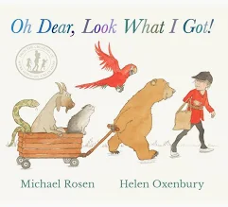  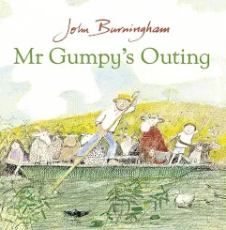  All creatures great and small |  | Communication and language  -Listen to rhymes, poems and songs  -To be able to tell a long story  -Develop their pronunciation  -To be able to express their point of view and debate when they disagree  -Use talk to organise themselves and their play using well formed sentences  -to use conjunctions  -Retell stories in their own words
Mathematical development  Counting on to add  Counting back to subtract  Counting to 20  Doubling  Having and sharing  Odds and evens  Mass, Volume and capacity  Money  Data | Physical development  -To match their developing skills to tasks and activities  -Choose the right resources to carry out their plan  -Collaborate with others to manage large items  -To refine movement skills with control and grace  -To develop overall body/core muscle strength  -To develop fine motor skills/foundations of a handwriting style which is fast and efficient |  | Things to remember  Book bags - Monday  PE day - Monday

