

**Year 3 Summer 2  
Groovy Greeks**

**Maths**

**Chapter 6: Mass**

* Reading Weighing Scales
* Solving Word Problems

**Chapter 7: Volume**

* Measuring volume in Millilitres
* Measuring capacity in Millilitres
* Measuring volume in Millilitres and Litres
* Measuring capacity in Millilitres and Litres
* Writing volume in Millilitres and Litres
* Writing capacity in Millilitres and Litres
* Solving word problems

**Chapter 9: Time**

* Converting minutes to seconds
* Converting seconds to minutes
* Finding number of days

**Chapter 13: Lines and Shapes**

* Identifying Perpendicular Lines
* Identifying Parallel Lines
* Finding Horizontal and Vertical Lines
* Drawing 2D Shapes
* Describing 3D Shapes

**RE**

**Would visiting the River Ganges feel special to a non-Hindu?**

* I can explain why water is important
* I can describe a Hindu ritual that happens at/in the River Ganges and explain why this is important and significant to the Hindus taking part in it
* I can empathise with the special feelings a Hindu might experience when taking part in a ritual at the River Ganges

**English**

**English Texts:**   
  
**Herakles**,by Simon Spence  
  
**Year 3 Writing Assessment Objectives:**

* write for both fictional and non-fictional purposes, drawing on their reading to inform the vocabulary and grammar of their writing
* describe settings and characters using expanded noun phrases
* use adverbs to express time
* use a range of co-ordinating and subordinating conjunctions
* use prepositions to express place and time
* maintain Standard English forms, e.g. using a/an correctly
* begin to use paragraphs to structure writing
* spell most words correctly, adding prefixes and suffixes appropriately, spelling the correct form of homophones and spelling all common exception words correctly (KS1 and Y3)
* use the diagonal and horizontal strokes needed to join some letters
* make simple additions, revisions and proof-reading corrections to their own writing

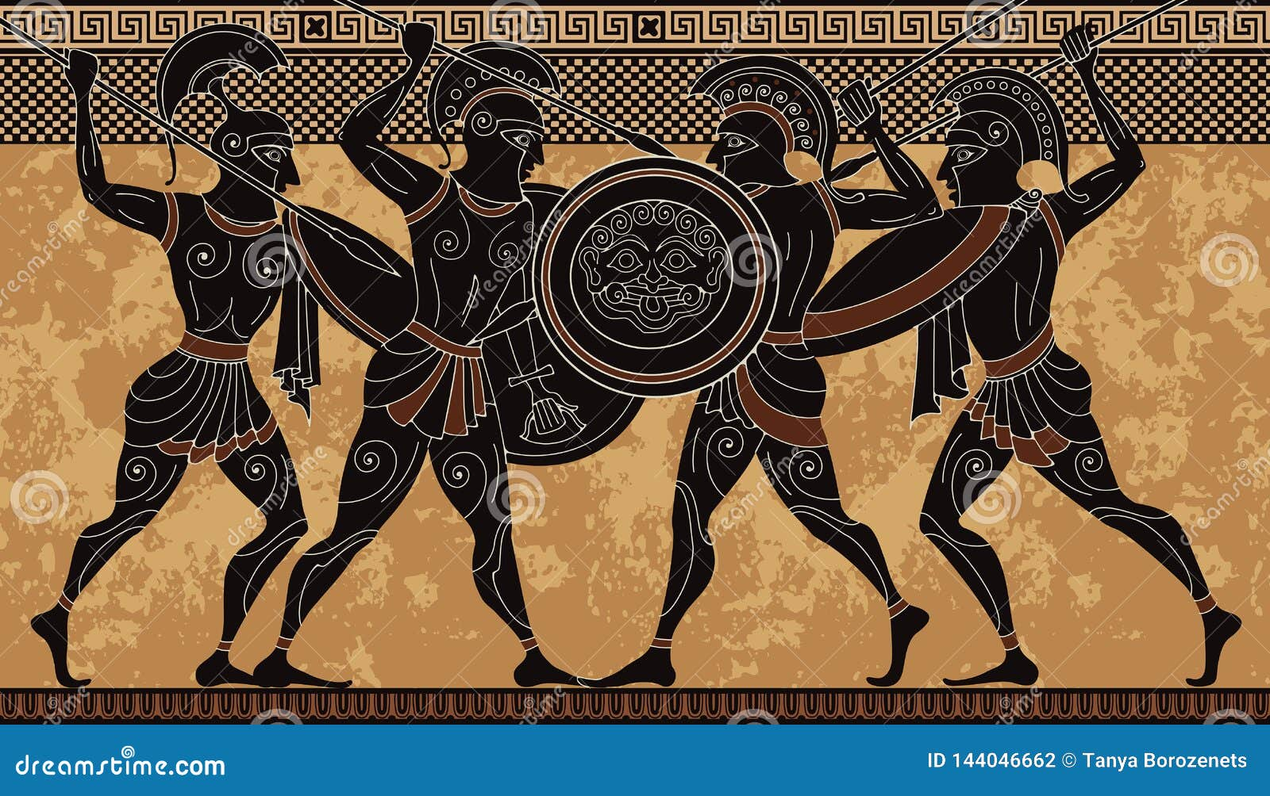

**Science**

**National Curriculum objectives**

* recognise that they need light in order to see things and that dark is the absence of light
* notice that light is reflected from surfaces
* recognise that light from the sun can be dangerous and that there are ways to protect their eyes
* recognise that shadows are formed when the light from a light source is blocked by an opaque object
* find patterns in the way that the size of shadows change

**Progression in skills objectives**

* Notice that light is reflected from surfaces
* Recognise that light from the sun can be dangerous and that there are ways to protect eyes
* Recognise that light from the sun can be dangerous and that there are ways to protect eyes
* Find patterns in the way that the size of shadows change

**History**

**National Curriculum objectives**

Ancient Greece – a study of Greek life and achievements and their influence on the western world

**Progression in skills objectives**

* Compare with our life today
* Identify and give reasons for different ways in which the past is represented
* Distinguish between different sources – compare different versions of the same story
* Use a range of sources to find out about a period
* Observe small details – artefacts, pictures
* Select and record information relevant to the study
* Begin to use the library and internet for research
* Communicate their knowledge through:

-Discussion….

-Drawing pictures…

-Drama/role play..

-Making models…..

-Writing..

-Using ICT…

**Computing**

**National Curriculum objectives**

* Use technology safely, respectfully and responsibly
* recognise acceptable/unacceptable behaviour
* identify a range of ways to report concerns about content and contact.

**Progression in skills objectives**

* Create a simple animation
* Create an animation with a detailed storyboard

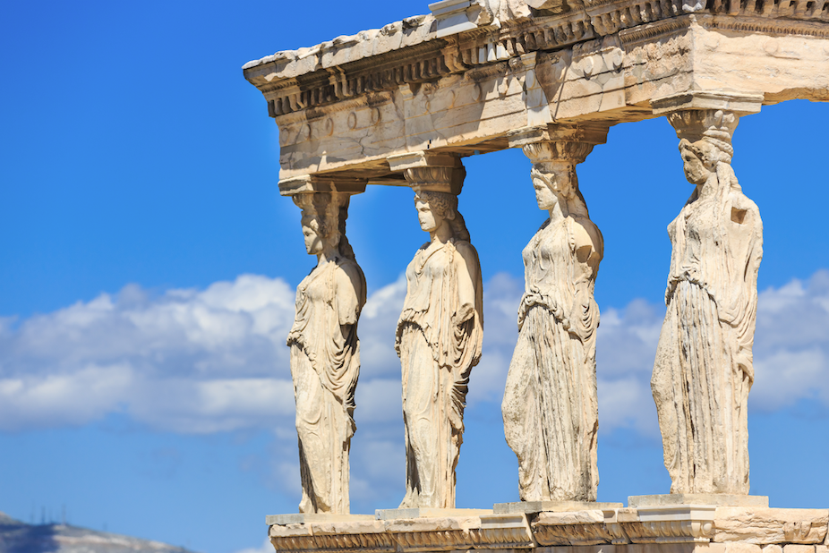

**Oracy**

**National Curriculum:**

* Participate in discussions, presentations, performances, role play, improvisations and debates
* Gain, maintain and monitor the interest of the listener(s)
* Consider and evaluate different viewpoints, attending to and building on the contributions of others
* Select and use appropriate registers for effective communication

**Progression in Skills:**

* Respond to the opinions of others in the group e.g. ‘Everyone on my table thinks the boy made the right choice. I agree with them.’
* Able to initiate conversations with unfamiliar adults (in school or in safe environment) and pupils.
* Exaggerate to make a story more interesting e.g. ‘I was so tired I could have slept for a week!’
* Able to understand another’s point of view and show whether they agree or disagree e.g. ‘I know why you think the boy is naughty but I don’t think he did it on purpose.’
* Aware of the need to use more formal language with adults e.g. ‘Please could I have another pencil?’ (to the teacher) or ‘Give me/pass me another pencil (to a peer).’

**Music**

**National Curriculum:**

* Play and perform in solo and ensemble contexts, using their voices and playing musical instruments with increasing accuracy, fluency, control and expression.
* Improvise and compose music for a range of purposes using the inter-related dimensions of music.
* Listen with attention to detail and recall sounds with increasing aural memory.
* Use and understand staff and other musical notations.
* Appreciate and understand a wide range of high-quality live and recorded music drawn from different traditions and from great composers and musicians.
* Develop an understanding of the history of music.

**Progression in Skills:**

* Pupils will explore how music has developed through different periods, styles and cultures in regards to -  
  • Pulse  
  • Tempo  
  • Rhythm  
  • Dynamics  
  • Pitch

• Texture

* Pupils will be able to constructively express their thoughts on performances including peer feedback developing listening skills and musical vocabulary.

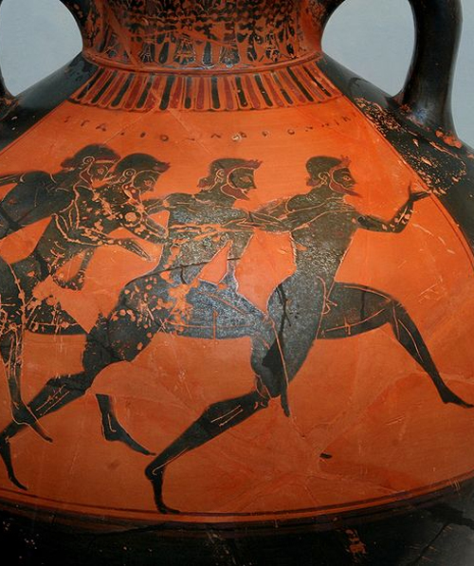

**Spanish**

**Going on a picnic in Spaon**

**National Curriculum:**

* listen attentively to spoken language and show understanding by joining in and responding
* explore the patterns and sounds of language through songs and rhymes and link the spelling, sound and meaning of words
* engage in conversations; ask and answer questions; express opinions and respond to those of others; seek clarification and help
* speak in sentences, using familiar vocabulary, phrases and basic language structures
* develop accurate pronunciation and intonation so that others understand when they are reading aloud or using familiar words and phrases
* present ideas and information orally to a range of audiences
* read carefully and show understanding of words, phrases and simple writing
* appreciate stories, songs, poems and rhymes in the language
* broaden their vocabulary and develop their ability to understand new words that are introduced into familiar written material, including through using a dictionary
* write phrases from memory, and adapt these to create new sentences, to express ideas clearly
* describe people, places, things and actions orally and in writing
* understand basic grammar appropriate to the language being studied, including (where relevant): feminine, masculine and neuter forms and the conjugation of high-frequency verbs; key features and patterns of the language; how to apply these, for instance, to build sentences; and how these differ from or are similar to English.

**Progression in Skills:**

* Can say and understand nouns for picnic food and drinks
* Can remember, say and recognise 6 colours and numbers to 15
* Can understand, enjoy and join in with a story
* Can write a short sentence in Spanish using a model
* Can ask the question where do you live and give an answer

**P.E**

**Athletics**

**National Curriculum:**

* Pupils should continue to apply and develop a broader range of skills, learning how to use them in different ways and to link them to make actions and sequences of movement. They should enjoy communicating, collaborating and competing with each other. They should develop an understanding of how to improve in different physical activities and sports and learn how to evaluate and recognise their own success.
* Develop flexibility, strength, technique, control and balance [for example, through athletics and gymnastics].
* Compare their performances with previous ones and demonstrate improvement to achieve their personal best.

**Progression in Skills:**

* Take part in basic scoring of different athletics events
* When questioned, show understanding of their role in team relay performance
* Compete with others and record points
* Link running and jumping activities with some fluency and consistency
* Control movements and body actions in response to specific instructions
* Jump for height and distance with control and balance
* Run at different speeds according to event and instruction
* Throw a variety of objects using recognised throws
* Throw more accurately and over greater distances
* Run as part of a relay team
* Identify how to improve their own and others’ work, and be tactful

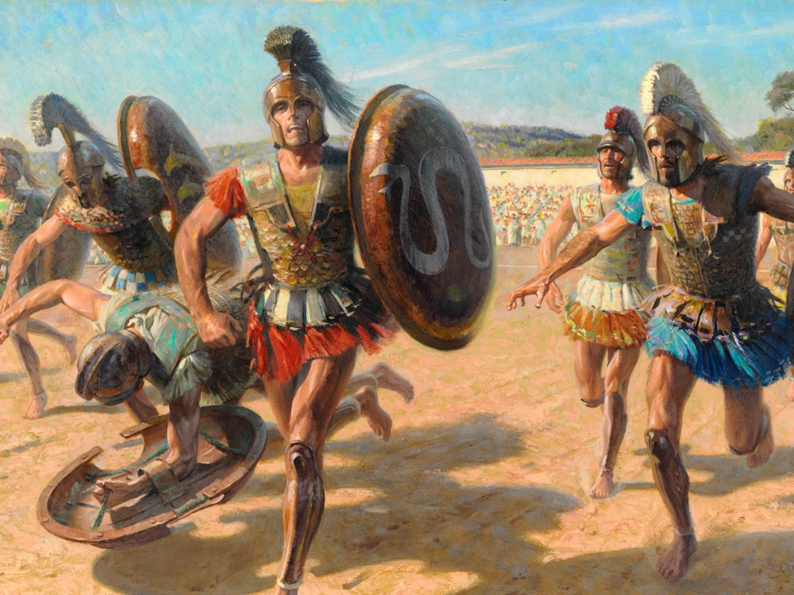

**Art**

**National Curriculum:**

* Pupils should be taught to develop their techniques, including their control and their use of materials, with creativity, experimentation and an increasing awareness of different kinds of art, craft and design.
* Pupils should be taught: to create sketch books to record their observations and use them to review and revisit ideas
* to improve their mastery of art and design techniques, including drawing, painting and sculpture with a range of materials [for example, pencil, charcoal, paint, clay]
* about great artists, architects and designers in history

**Progression in Skills:**

* Use their sketchbook to collect and record visual information from different sources.
* Annotate work in sketchbook.
* Join clay adequately and work reasonably independently.
* Construct a simple clay base for extending and modelling other shapes
* Plan, design and make models.
* Work on their own, and collaboratively with others, on projects in 2 and 3 dimensions and on different scales
* Talk about the processes used to produce a simple print.
* To explore pattern and shape, creating designs for printing.

**PHSE – The Story Project**

**The Hundred Dresses** by Eleanor Estes

**Lesson Objectives:**

* I can tell you the benefits of community participation on my mental well being.
* I can tell you how music can benefit my mental well being.
* I can tell you why it is important not to give up when something is hard.
* I can use a five point scale to tell you how hard I am finding my work and I can tell you some strategies that help me when my work is hard.
* I can give constructive support and feedback to others.

**PHSE – My Happy Mind**

**Engage**

**Lesson Objectives:**

* That to engage means to pay attention and put effort into something.
* How their feelings affect their ability to do well in an activity and learn that they have to feel good to do good.
* What Big Dream Goals are.
* How to use perseverance and resilience to help them not give up on something.
* That they have to Believe to Achieve.
* How to set their own Big Dream Goals.

**Progression in Skills:**

* H39: about hazards (including fire risks) that may cause harm, injury or risk in the home and what they can do to reduce risks and keep safe
* H40: about the importance of taking medicines correctly and using household products safely (e.g following instructions safely)
* H41: strategies for keeping safe in the local environment or unfamiliar places (rail, water, road) and firework safety; safe use of digital devices when out and about
* H43: about what is meant by first aid; basic techniques for dealing with common injuries
* H44: how to respond and react in an emergency situation; how to identify situations that may require the emergency services; know how to contact them and what to say