
Pupil premium strategy statement
This statement details our school’s use of pupil premium (and recovery premium for the 2021 to 2022 academic year) funding to help improve the attainment of our disadvantaged pupils.

It outlines our pupil premium strategy, how we intend to spend the funding in this academic year and the effect that last year’s spending of pupil premium had within our school.

- Academy overview
Detail | Data
Academy name | Co-op Academy Penny Oaks
Number of pupils in academy | 178
Proportion (%) of pupil premium eligible pupils | 35%
Academic year/years that our current pupil premium strategy plan covers (3 year plans are recommended) | 2024/25  2025/26  2026/27
Date this statement was published | September 2024
Date on which it will be reviewed | September 2025
Statement authorised by | Michelle Khambhaita
Pupil premium lead | Louise Haywood
Governor / Trustee lead | Liz Upton

Funding overview
Detail | Amount
Pupil premium funding allocation this academic year | £113,625
Recovery premium funding allocation this academic year | £0
Pupil premium funding carried forward from previous years (enter £0 if not applicable) | £0
Total budget for this academic year  If your school is an academy in a trust that pools this funding, state the amount available to your school this academic year | £113,625

Part A: Pupil premium strategy plan

Statement of intent

Statement of intent
At Co-op Academy Penny Oaks, we have a high percentage of children who are eligible for pupil premium funding and passionately believe that these children should not suffer disadvantage because of their circumstances. We aim to use our pupil premium funding to “level the playing field” for our children so that they have the same experiences and opportunities as children who are not from disadvantaged backgrounds. We strive to provide our children with the very best teaching and learning experiences to adequately prepare them for the next stage of their education ensuring that their disadvantage is not a barrier to their success. We aim to focus our spending over the next 3 years on continuing to improve the quality of teaching, focussing on delivering curriculum enhancements through our drivers: aspirations, healthy lifestyles and experiences, and supporting the mental health and well-being of our children.
At Co-op Academy Penny Oaks, our pupils sometimes face challenges which have the potential to hinder equitable access to education, when compared to their peers nationally. Penny Oaks serves a community which is in the bottom 10% of the Index of Multiple Deprivation (IMD).
- The majority of our children arrive at school with low standards of English and communication, which are below their peers Nationally. For many this barrier is linked to acquisition of English and a lack of modelled English language beyond school, 75% speak English as an additional language; speaking 15 different languages other than English. The proportion of pupils from minority ethnic backgrounds is much higher than the national average at 95%.
- The proportion of pupils who have SEN and/or disabilities is below average, with 16% requiring SEND support,
- Child poverty is an acute problem within the community – 35% of the schools population is disadvantaged (Pupil Premium)
- The proportion of pupils who join and leave the school other than at the usual times is high and many children who arrive at school have little or no English, many of which have not been to a school in their country of origin.
- The early years includes a Nursery where children attend part time, and one Reception class where children attend full time.
- Due to high levels of economic deprivation, many of our children have limited resources outside of school to provide out of hours learning support, or high-quality life experience.
- Our children enter Nursery and Reception well below age related expectations in many areas, and are generally below in all areas of the EYFS curriculum. We have identified limited experience of life outside that of their immediate locality as having an impact on their ability to learn from the world around them. Many are unable to play, talk or investigate at a level comparable to their peers nationally.

Challenges
    - This details the key challenges to achievement that we have identified among our disadvantaged pupils.

Challenge number | Detail of challenge
1 | High level of English as an Additional Language
2 | Lack of knowledge related to nutrition
3 | Lack of physical exercise
4 | Poor living conditions causing poor mental health and well-being
5 | Lack of aspirations and knowledge around careers
6 | Lack of experiences
7 | Difficulty in providing for basic needs

Intended outcomes
    - This explains the outcomes we are aiming for by the end of our current strategy plan, and how we will measure whether they have been achieved.

Intended outcome | Success criteria
Effect of children’s attainment and progress is mitigated | At least 80% of children “on track” for EXS in each year group in reading, writing and maths
Children and their families regularly consume a healthy diet | Children have a good understanding of what constitutes a healthy diet  By the end of KS2 Children have the cooking skills to prepare simple healthy meals  Parents are engaged with our nutrition programme and are confident in identifying and preparing a healthy diet  Children and parents understand the link between a healthy diet and performance
Children are physically fitter | Children have more exercise throughout the day  Children understand the link between exercise and performance  Children’s skills in a variety of spots is improved
Children have good mental health | Children will know strategies to keep them mentally well  Children know how to relax  Children know who they should talk to when they are feeling mentally unwell  Children recognise when they are mentally unwell and need to utilise well-being strategies
Children are aspirational for their future | Children know about the recruitment process  Children are aware of a wide range of jobs on offer to them  Children can discuss their future aspirations and identify what they need to do to achieve these
Children attend school every day | PP children achieve 95% or higher attendance
Children have a wide range of experiences | Children’s range of vocab will increase  Children’s imagination and inspiration for writing will increase  Children will have a better understanding of cultural and societal experiences
Children’s basic needs are met | All children have adequate footwear  All children have adequate outerwear  All children/families have adequate food and drink
Increase the proportion of parent engagement in the academy | Number of parents attending parents’ evening increase  Number of parents attending parent workshops and drop-ins increases  Number of parents accessing communication tools increases (Parentmail, role out of Arbor App)

Activity in this academic year
  - This details how we intend to spend our pupil premium (and recovery premium funding) this academic year to address the challenges listed above.

Teaching (for example, CPD, recruitment and retention)
Budgeted cost | £ 57,000

Activity | Evidence that supports this approach | Challenge number(s) addressed
Delivering the Welcomm programme to targeted nursery, reception and Year 1 children | The WellComm Toolkit: Impact on Practitioner Skills and Knowledge and Implications for Evaluation Research | 1
TLAC training for all staff  GDS writing CPD  Times tables CPD for all staff | Effective Teacher CPD and CPD Leadership: What does it look like in schools? – HISP Research School – March 2020 | 1
Phonics support - dedicated teacher for 5x ½ days to lead phonics catch-up | The importance of early phonics improvements for predicting later reading comprehension  Kit S. Double, Joshua A. McGrane, Jamie C. Stiff, Therese N. Hopfenbeck | 1
Artist in school 6x a year  to work with classes (CPD for teachers as well as expert delivery for children) | Standley, J.M. (Abstract ) 3 Does Music Instruction Help Children Learn to Read? Evidence of a MetaAnalysis. Update Applications of Research in Music Education, 27.1, pp. 17-32 | 4
Nutrition Lessons (CPD for teachers as well as expert delivery for children)  . | Impact of the Nutrition for Life Program on Junior High Students in New York State - Carol M. Devine,Christine M. Olson,Edward A. Frongillo Jr., | 2
Singing lessons and instrument tuition from choral director and qualified musician (CPD for teachers as well as expert delivery for children) | Catterall, J. S., Dumais, S. A., & Hampden-Thompson, G. The arts and achievement in at-risk youth: Findings from four longitudinal studies National Endowment for the Arts, Washington | 4

Targeted academic support (for example, tutoring, one-to-one support structured interventions)
Budgeted cost | £ 28,500

Activity | Evidence that supports this approach | Challenge number(s) addressed
Specific Mentor time (targeted interventions) | The Contribution of Learning Mentors to Achievement  Margaret Roberts | 4
Additional Targeted Phonics Interventions | A national intervention in teaching phonics: A case study from England | 1
Third Space Learning | A review of interventions to improve primary school maths achievement  June 2016 - April 2019 EEF | 1

Wider strategies (for example, related to attendance, behaviour, wellbeing)
Budgeted cost | £28,775

Activity | Evidence that supports this approach | Challenge number(s) addressed
Use of nutrition lead to host parent and child cooking sessions and “dance N Dine” sessions after school | Interventions that involve parents to improve children's weight-related nutrition intake and activity patterns – what nutrition and activity targets and behaviour change techniques are associated with intervention effectiveness? | 2 7
Small group music tuition for children | Standley, J.M. (Abstract ) 3 Does Music Instruction Help Children Learn to Read? Evidence of a MetaAnalysis. Update Applications of Research in Music Education, 27.1, pp. 17-32 | 4
Careers week | Cummings, C., Laing, K., Law, J., McLaughlin, J., Papps, I., Todd, L., & Woolner, P. 1 Can Changing Aspirations And Attitudes Impact On Educational Attainment? Joseph Rowntree Foundation | 5
Y6 workforce | Gorard, S., See, B. H., & Davies, P. The impact of attitudes and aspirations on educational attainment and participation Joseph Rowntree Foundation | 5
Welfare fund | Effects of Home Environment on Parental Attitudes towards the Educational Attainment of Primary School Pupils in Winneba Township, Ghana | 7
Breakfast club | The Impact of Breakfast Clubs on Pupil Attendance and Punctuality  Donald Simpson - First Published November 1, 2001 Research Article | 7
Rethink Food subscription | Impact of the Nutrition for Life Program on Junior High Students in New York State - Carol M. Devine,Christine M. Olson,Edward A. Frongillo Jr. | 2  7
Residential subsidy | Effect of School Quality and Residential Environment on Mode Choice of School Trips – Silvia He | 6
Trips subsidy | Effect of School Quality and Residential Environment on Mode Choice of School Trips – Silvia He | 6
Improving outdoor learning provision - Creating Active lunchtime | Outdoor adventure learning – EEF | 6
Attendance Officer | School attendance and absence in England: Working with data to inform policy and practice beneficial to young people | 6
Rock Steady | Standley, J.M. (Abstract ) 3 Does Music Instruction Help Children Learn to Read? Evidence of a MetaAnalysis. Update Applications of Research in Music Education, 27.1, pp. 17-32 | 4
Forest Schools - Nursery Children | Outdoor Adventure Learning EFF | 3 6
Grow to School | Outdoor Adventure Learning EFF | 2 3 4 6
Subsidise Clubs | Nuffield Foundation: Highlighted that sports clubs are linked to higher academic attainment at age 11. UK Parliament Evidence (2025): Emphasized that enrichment activities are crucial for mental health, building confidence, and improving school attendance. | 5 6

Total budgeted cost
Total budgeted cost | £ 113,625

Part B: Review of outcomes in the previous academic year

Pupil premium strategy outcomes
  - This details the impact that our pupil premium activity had on pupils in the 2024 to 2025 academic year.

Pupil premium strategy outcomes
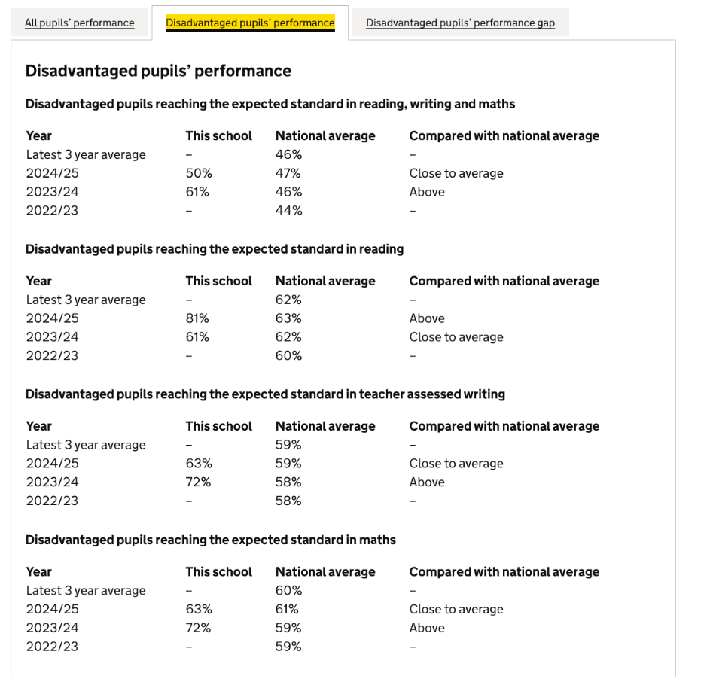
Our pupil premium children have better outcomes than those children who receive PP funding nationally in all subjects at the end of KS2

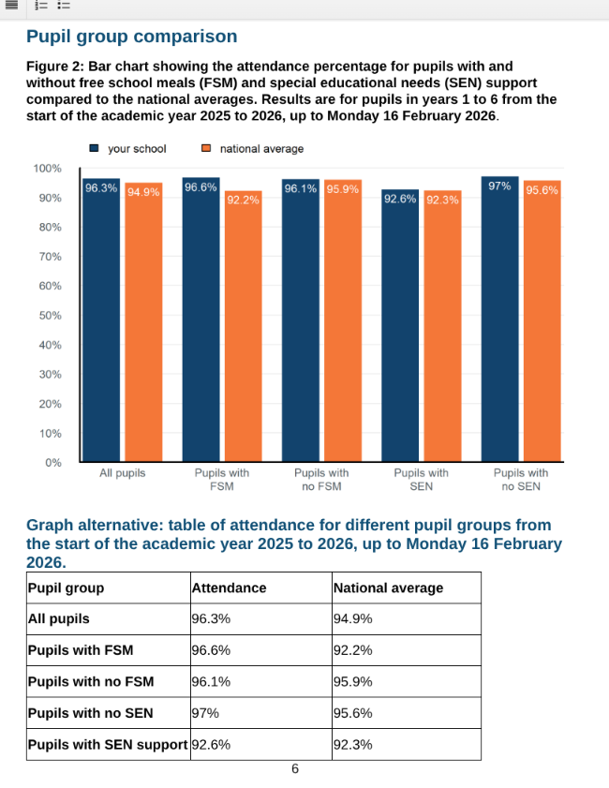
Our pupil premium children have better attendance than children who do not receive PP funding and better than those who do receive PP funding nationally.

Our internal data shows that a high proportion of our PP children attend our parent events and take advantage of our wider curriculum offer.

A large majority of our PP children use our free breakfast club

A large majority of our PP children access our wider PD offer and are prioritised for these events

Externally provided programmes
Programme | Provider
Accelerated Reader | Renaissance
Third Space Learning | Virtual class
Reading Plus | Dream box
Clicker 8 | Crick Software
IDL | IDL Group
Now Press Play | Now Press Play
Purple Mash | 2simple

