**Science - Year 6**

Autumn Term – Light

Animals including humans

**Science links**

**Light**

Notice light is reflected from surfaces (Y3)

Find patterns in the way that the size of shadows change (Y3)

Light is a form of energy that enables us to see the world around us (Y3)

Light comes from different sources (Y3)

**Animals including humans**

Identify, name, draw and label the basic parts of the human body and say which part of the body is associated with each sense (Y1)

Describe the importance for humans of exercise, eating the right amounts of different types foods and hygiene (Y1)

Identify that animals, including humans, need the right types and amount of nutrition, and that they cannot make their own food; they get nutrition from what they eat (Y3)

**Art links**

**Light**

Overlay colours (Y5)

Demonstrate a secure knowledge of primary and secondary colours (Y5)

**English links:**

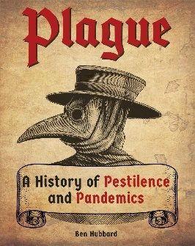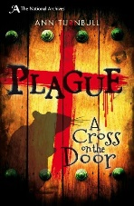



Experiences