**Science - Year 3**

Summer Term – Forces and magnets

Light

**Science links**

**Forces and magnets:**

Some materials are magnetic (Y1)

Describe how the shapes of solid objects made from some materials can be changed by squashing, bending, twisting and stretching (Y2)

**Light:**

Compare and group together a variety of everyday materials on the basis of their simple physical properties (Y2)

**History links:**

**Forces and magnets:**

The Wright brothers designed, built and flew the first engine powered aeroplane in December 1903 (Y2)

The Wright brothers were also known for inventing a way to steer an aeroplane (Y2)

The Wright brother invented wing warping to control the wings. Amelia Earhart became the first woman to fly solo across the Atlantic Ocean (Y2)

**English links:**

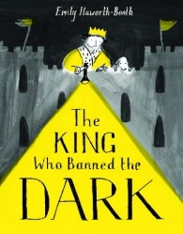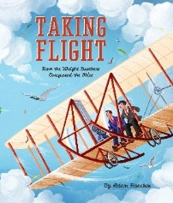



Experiences

