**Science - Year 2**

Summer Term – Living Things

Plants

**Science links**

**Living things:**

Identify and name a variety of common animals that are carnivores, herbivores and omnivores (Y1)

**Plants:**

Plants need water, nutrients and sunlight to grow (Y1)

Identify and describe the basic structure of a variety of common wild and garden plants including deciduous and evergreen trees (Y1)

Identify and describe the basic structure of a variety of common flowering plants; including trees (Y1)

Flowers are made up of roots, stems, leaves and flowers (Y1)

**Geography links**

**Living things:**

Investigate their surroundings (Y1)

The countries closer to the equator are warmer and the countries further away are the coldest (Y1)

In goa you would find Indian civet, the sloth bear, the Indian porcupine, the pangolin, the slender loris, the wild boar and the mongoose (Y1)

**English links:**

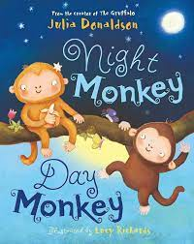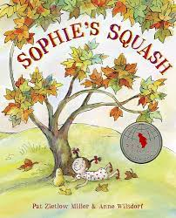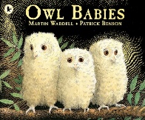

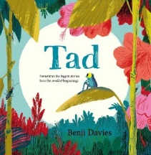

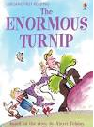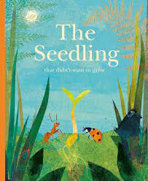

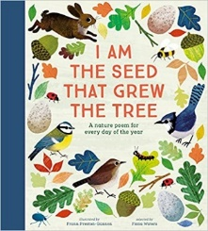

Experiences