**Science - Year 3**

Spring Term – Animals including humans

Plants

**Science links**

**Animals including humans:**

Identify and name a variety of common animals that are carnivores, herbivores and omnivores (Y1)

Describe and compare the structure of a variety of common animals (fish, amphibians, reptiles, birds and mammals including pets) (Y1)

Identify, name, draw and label the basic parts of the human body and say which part of the body is associated with which sense (Y1)

Describe the importance for humans of exercise, eating the right amount of different types of food and hygiene (Y1)

Describe the basic needs of animals, including humans, for survival (water, food, air) (Y2)

Animals and humans need food, water, air and shelter to survive (Y2)

Humans can only survive without water for three days (Y2)

**Science links**

**Plants:**

Spring is the season when plants start to grow again (Y1)

Seeds need to wait for conditions to be just right before they start to grow (Y2)

Bulbs can sprout new growth (Y2)

Observe and describe how seeds and bulbs grow into mature plants (Y2)

Find out and describe how plants need water, light and suitable a temperature to grow and stay healthy (Y2)

**English links:**

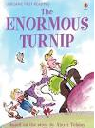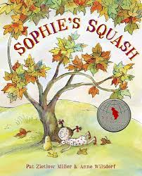



Experiences

